Using the Database

Search Directions
The database is searchable in two directions: on the opening screen, near the top left-hand corner, users can set the buttons to either ‘Target’ as their starting point, or to ‘Source’:

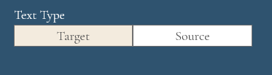

If the starting point is set to ‘target text’ (that is, the Anglo-Saxon text in Old English or Anglo-Latin), users ask the database to find the sources associated with this target text.
Examples:
Which sources were used for the composition of target text Aldhelm, Carmen ecclesiasticum 3?
Which sources were used for the composition of target text Blickling Homily 14?

If the starting point is set to ‘source text’, users ask the database to find the target texts that used this source.
Examples:
Which target texts (Anglo-Saxon authors, whether writing in Old English or Latin) used the biblical book of Job as a source?
Which target texts (Anglo-Saxon authors, whether writing in Old English or Latin) used Gregory the Great’s Moralia in Iob as a source?

Entering Authors and Texts
Enter the details of a chosen text, by either typing the author, the title, the edition or the text reference into one or more of the search windows:
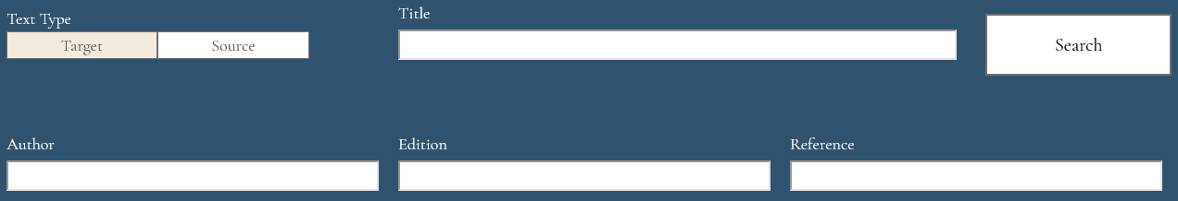

Example:
Type Blickling homily 14 under ‘Title’
or
Type Anon (OE) under ‘Author’
or
Type Morris 1874-80 under ‘Edition’
or
Type C.B.3.3.12 under ‘Reference’

Tip: using the ‘Title’ window is often the quickest way forward, as it uses predictive text to guess which title the user has in mind.
The Reference numbers used in the database are the so-called Cameron-Frank numbers, for Old English texts given in R. Frank and A. Cameron, ed., A Plan for the Dictionary of Old English (Toronto, 1973). Searching by Cameron-Frank number may be the best idea if the text is relatively obscure and without a clearly established title. For Latin texts it is the number given in the list of Anglo-Latin texts prepared by Michael Lapidge and Rosalind Love, preceded by L (e.g. L.N.100 for the Liber monstrorum).

Search Results
Once users click on ‘Search’, the database will locate and present the text searched for in a light grey bar nearer the bottom of the screen:
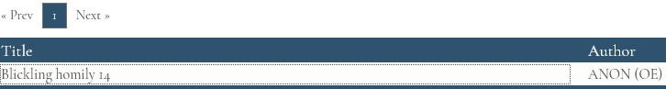

Click on the light grey bar with the text title (here ‘Blickling homily 14) to see the relevant search results:
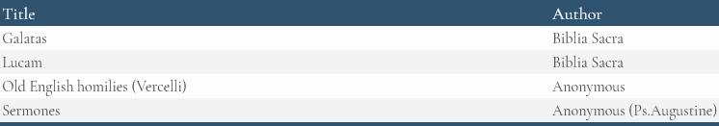

Click on any of the source texts listed in the light grey area to access further details of that text. In our example, clicking on ‘Galatas, Biblia Sacra (= Galatians, Bible) will produce this dark blue bar:

Within the dark blue bar users can see the target text location in question, the target text quotation and a siglum.
In our example, these details mean that, on clicking on the dark blue bar, uses will now be receiving the source details for the passage from Blickling homily 14 located at p. 165, lines 23-24 in the edition and which has the quotation ‘swa sanctus paulus… ne lybbe ic ac crist leofað’ and is linked to a source passage with the siglum SA1. (More information on Sigla below)

Full Details
The full range of results will appear on clicking on the dark blue bar:
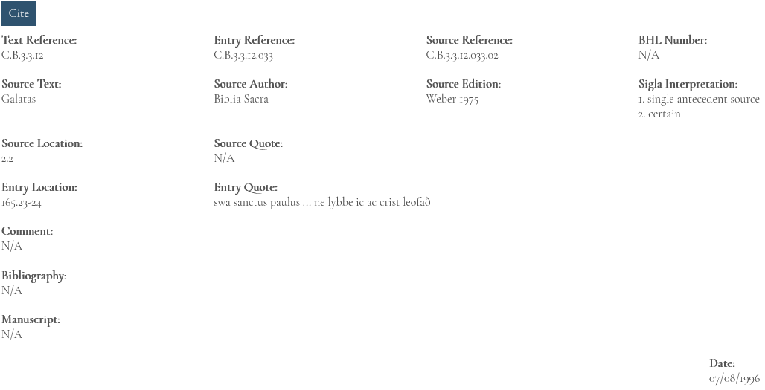
These results include the precise location of the target text passage and source text passage, reference numbers, an explanation of what the siglum means, bibliographical information, edition information, the relevant opening and closing words (or a full quotation if it is very short) from of the target text and the source text, comments and the date on which the entry was last updated.
For citations from the Bible, source quotations are often not given since they are so readily accessible.
The BHL number relates to the hagiographic sources, and refers to the number given for that text in Bibliotheca Hagiographica Latina (2 vols., Brussels 1898-1901; Subsidia hagiographica 6); with supplements in 1911 (Subsidia hagiographica 12) and 1986 (Subsidia hagiographica 70).

Author Names and Text Titles
Author names appear in the form most conventional in English, except for Beda (target texts authored by the Venerable Bede) and Biblia Sacra (the Bible). Many texts are anonymous; these are designated as follows:
Anon (OE): anonymous authors of texts written in Old English
Anon (Lat.): anonymous authors of texts written in Latin
The designation Anon (OE Martyrology) is used to isolate the nearly 300 text sections of the Old English Martyrology and which are very diverse in their source background.
Some texts will appear in both the target text and source text lists; thus Abbo of Fleury’s Passio Eadmundi appears as a target text because it was written in Anglo-Saxon England, but it also appears as a source text because it was used as a source by Anglo-Saxon authors, such as Ælfric, for his Life of St Edmund.

Re-attributions and New Identifications of Sources
In identifying authors we have tried to keep abreast of modern re-attributions and identification, but, since these are constantly changing, users should be prepared to look for other possibilities (e.g. by consulting Clavis Patrum Latinorum for patristic texts). Texts formerly ascribed to a known author but now of unknown authorship will appear, e.g., as Anonymous (Ps.Bede) or Anonymous (Ps.Gregory). Texts formerly attributed to one author, but now ascribed to another, might appear, e.g., as Quodvultdeus (Ps.Augustine).

Sigla
S single source
M one of multiple sources
SA antecedent source (that is, the source of a source, in an indirect relationship)
SX analogue (that is, a text with striking similarities with the target text, whose precise relationship and direction of indebtedness cannot however be established precisely)
1, 2, 3, certain, probable, possible
a and
o or

Examples:
S2 probable single source
M1a one of multiple sources, both of which were certainly used
M2o one of multiple sources, one of which was probably used

Further Text information
Additionally, on the screen which gives the search results, further above the links to the source entries, two dark grey bars will be visible:

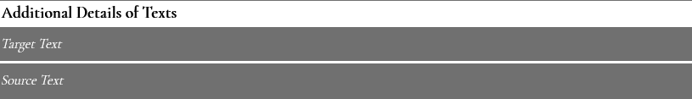

These lead to further information on the target text and source texts (esp. edition used, secondary bibliography and transmission information) when they are expanded by clicking:

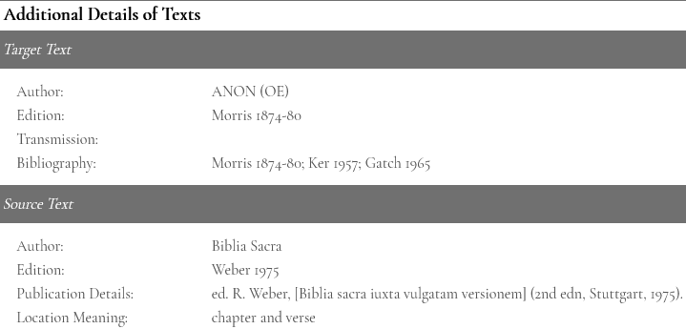

Bibliography
On the first screen of the database, a button near the top of the screen leads to the bibliographies used in the database.


This area gives full publication details for a variety of works cited in the database, under the three categories of target, source and secondary:



Target: Editions of target texts, e.g. Ælfric, Catholic homilies 1.1, Clemoes 1997
Source: Editions of source Texts, e.g. Vergil, Aeneid, Mynors 1969
Secondary: source studies, e.g. Turville-Petre 1963
At the end of the Source Bibliography, users can also find a list of abbreviations used, mainly for series such as PL (= Patrologia Latina) or journals such as LSE (= Leeds Studies in English).
The Bibliography includes under Secondary not only the expected modern critical studies which are cited within the database, but also some editions of texts which have been cited because they include significant discussions of sources, and some alternative editions of source Texts because they include significant variant versions which have been cited in the database. Thus Scragg 1992 may be listed as the specified edition of a target Text (the Vercelli Homilies) and as the specified edition of certain source texts which are only accessible in his apparatus or commentary, but also as a source study for the identification of particular sources. Fabricius 1719 is listed as the specified edition of certain source texts, but also appears under source studies when it is cited for its variant versions of other source texts.

Pinned Entries
Pinning entries is a way of storing the entries a user is interested in, as if on a clipboard. These entries can be from multiple searches and visits to the database.
Each source entry will have a pin icon towards the left of the screen.
If users click on the icon, the icon will fill in white and the entry will be pinned, that is, copied to the ‘clipboard’.
Once entries have been pinned, users can find them in the pinned entries page via the navigation bar:
On opening the area for pinned entries, users will then find all entries which they had designated as pinned during their searches:
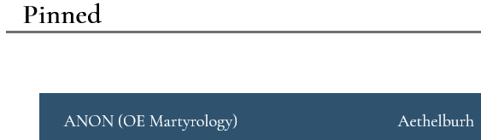

The standard print and download records functions are available here so that users are able to print or download specific records of interest:

In order to unpin entries, users can open the entry in the pinned area and click on the pin icon again to remove it. Alternatively, they can return to the main part of the database, find the relevant entry and unpin it there.
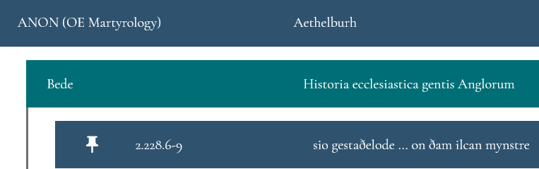

Records in the pinned entries page will be sorted by their target text first, then source text. They are initially hidden until clicked on, like the entries in the search section.

Contact
In case of questions or problems arising from use of the database, feel free to contact:
Dr Christine Rauer
University of St Andrews
cr30@st-andrews.ac.uk

Copyright and Permissions
The data in this application is the copyright of the Fontes Anglo-Saxonici project, and use of it in publications should be acknowledged as described. Users are welcome to copy the application for their own use or for others, or to network it, as long as its form is not changed and acknowledgement is made to the project. You may not sell or hire this product in any form.

Further Reading
Biggs, F. M., T. D. Hill and P. E. Szarmach, Sources of Anglo-Saxon Literary Culture: A Trial Version, Medieval and Renaissance Texts and Studies 74 (Binghamton, 1990) [an early publication of the SASLC project]
A. S. Cook, Biblical Quotations in Old English Prose Writers, 2nd edn (New York, 1903) [an early example of source study, focusing on biblical material]
Frantzen, A. J., Desire for Origins: New Language, Old English and Teaching the Tradition (New Brunswick, 1990) [important critique of source study]
Lapidge, M., The Anglo-Saxon Library (Oxford, 2006) [partly based on Fontes data]
O’Brien O’Keeffe, K., ‘Source, Method, Theory, Practice: On Reading Two Old English Verse Texts’, Textual and Material Culture in Anglo-Saxon England, ed. D. Scragg (Cambridge, 2003), pp. 161-81 [discussion of intertextual relationships; provided the term ‘target text’ to the Fontes project]
Ogilvy, J. D. A., Books known to the English, 597-1066 (Cambridge, MA, 1967) [a forerunner of the Fontes Anglo-Saxonici project]
Rauer, C., Beowulf and the Dragon: Parallels and Analogues (Cambridge, 2000), pp. 9-11 [definitions of key terms, including source and analogue]
SASLC / SOEALLC: https://hcommons.org/groups/sources-of-old-english-and-anglo-latin-literary-culture/ [a US-based sister project to Fontes Anglo-Saxonici]
Wright, C. D., ‘Sourcing Old English Anonymous Homilies: The Pioneers (Max Förster, Rudolph Willard, and J. E. Cross)’, The Anonymous Old English Homily: Sources, Composition, and Variation, ed. W. Rudolf and S. Irvine, Medieval and Renaissance Texts and Authors 25 (Leiden, 2020), pp. 36-84 [a recent example of source study, with homiletic focus]

11/03/2021

