School of Mathematics and Statistics Newsletter

May 2025

Congratulations to ...
• Lars Olsen who received the Students’ Association 2024-25 Teaching Award for Outstanding Teacher in Science and Medicine, which recognised in particular his support for the progression of students as they transition between different levels of study. Congratulations also to maths postgraduates Murray White and Joe Edwards who were two of the four postgraduate students shortlisted for the Students Association award for Outstanding Graduate Teacher in Science and Medicine.

Welcome to ...
• Natalia Jurga who started as a Lecturer in the School on 1st May to work in the Analysis Group. Natalia is already well-known around the School having been at St Andrews since April 2020, first as an EPSRC postdoc and then as a Leverhulme Trust Early Career Fellow.
• Simon Daley-Yates who joined the Solar and Magnetospheric Theory Group on 1st May to work with Ineke de Moortel on modelling of MHD waves and solar coronal heating. Simon was a PhD student in Birmingham and held post-doctoral positions at CEA-Saclay in Paris and in Cambridge. Recently, he has been working with Moira Jardine in Physics & Astronomy on stellar magnetic fields, and so is no stranger to St Andrews.
• Jesse Alexander, joined the NCAS-St. Andrews group on 1st May as an intern of Ioana Colfescu and will be working on wildfires in Scotland.

Visitors
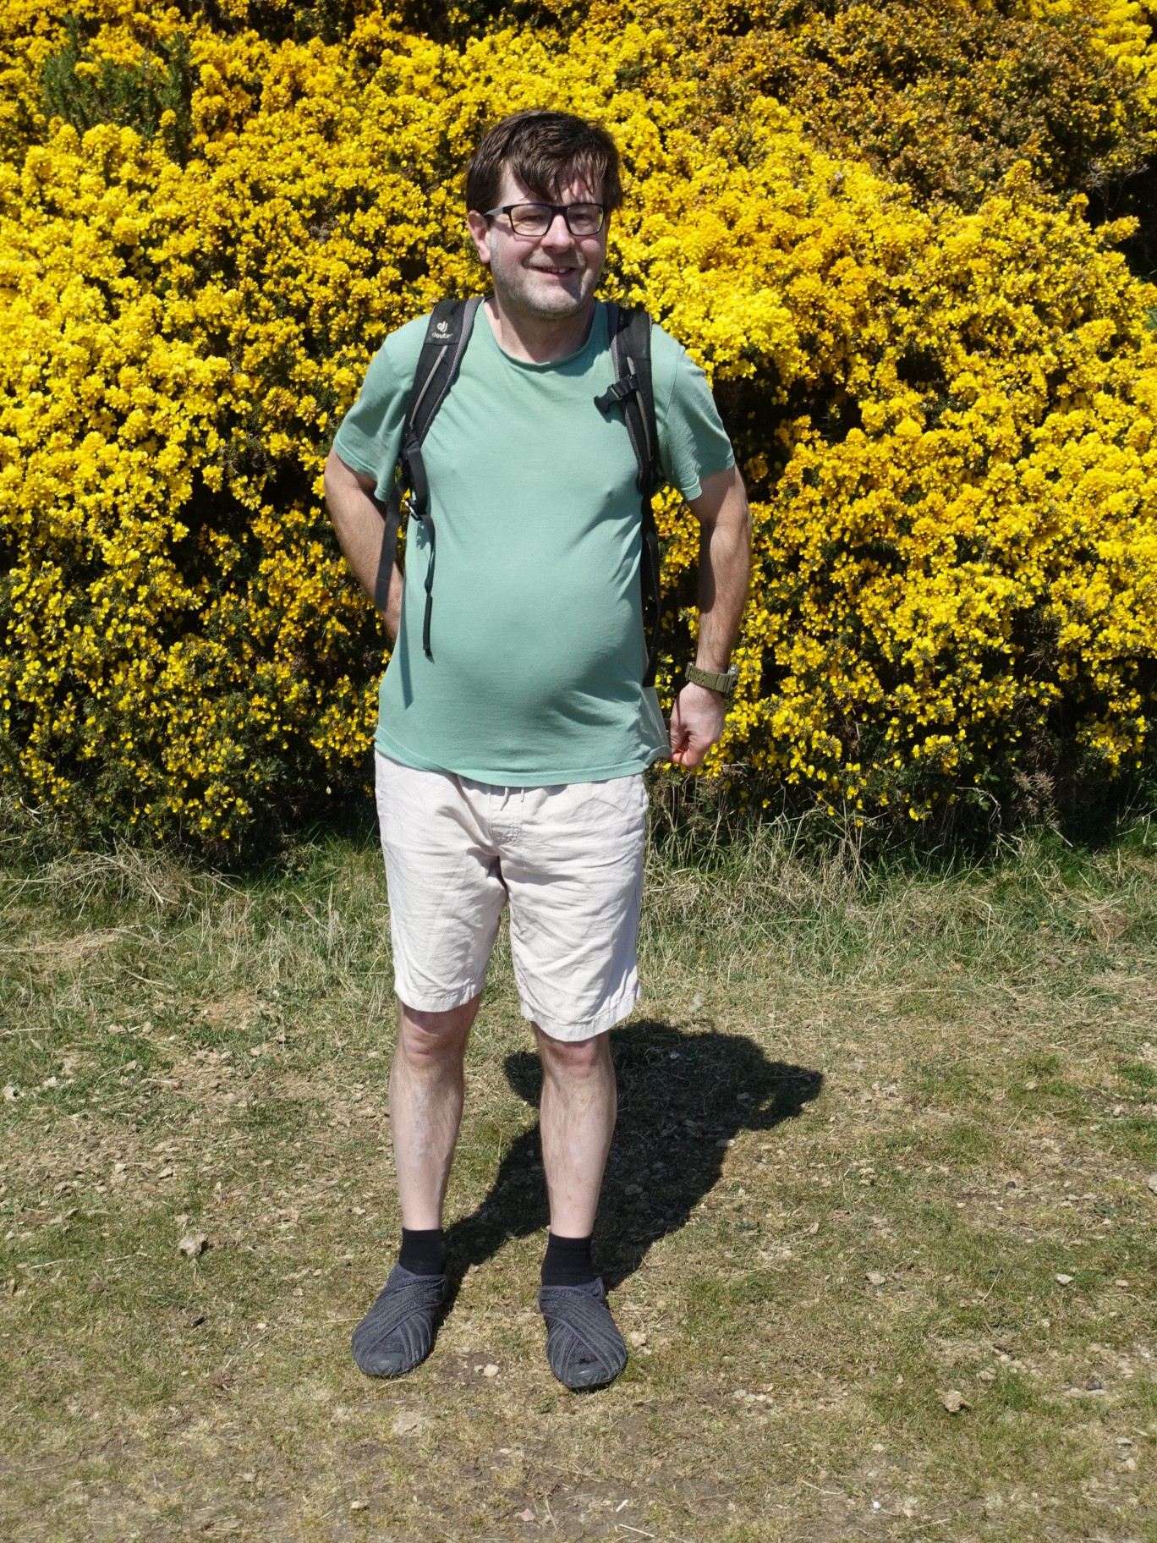
• On 23rd April, the School welcomed back alumnus Andrew Templeton (BSc Mathematics, 2006) who now works in investment banking as head of UK Financial Institutions (FIG) Debt Capital Markets (DCM) group at BNP Paribas, one of the largest banks in Europe. Whilst in St Andrews, Andrew gave our first Maths Alumni Careers Talk for students, in which he shared insights into financial careers and general employability advice.
• Wiesław Kubiś, from the Czech Academy of Sciences in Prague, visited Peter Cameron from 30th April to 12th May to work on homogeneous structures and related topics.
Wiesław on Drumcarrow Crag, a fine viewpoint four miles southwest of St Andrews where the yellow gorse has been spectacular this spring. A walk along the Fife Pilgrim Way to Drumcarrow Crag is strongly recommended! – Ed

Conferences, Talks and Visits
• On 1st May, Ana de Orellana attended a one day workshop in Harmonic Analysis and PDEs at the University of Cork.
• Saeed Shaabanian visited the University of Warwick to give a talk titled ‘A natural connection between recurrence Laws in ϕ-mixing dynamical systems’. This was part of the seminar series Dynamics and Group Geometry Early Researchers Seminar (DAGGER). The aim of the series is to provide an accessible setting where postgraduate students and postdocs can talk about their research and interests in dynamics, geometry, topology and related areas.
• On 16th April Firdavs Rakhmonov gave a talk entitled ‘Discrete Fourier analysis in vector spaces over finite fields: quotients of distance sets, exceptional projections, and incidence geometry’ in the Modern Applied Algebra and Arithmetic Seminar at Moscow State University.
• Natalia Jurga was a Visiting Professor at di Toppo Wassermann University School in Udine, Italy from 5-9th May. She gave a minicourse to students on ‘Self-projective sets’ and also spoke to them about pursuing a PhD in the UK. For the rest of the week she was working with Giovanni Panti.
• This year’s Scottish Combinatorics Meeting (SCM) and Postgraduate Combinatorics Conference (PCC) were co-located at the University of Glasgow from 28th April-2nd May. Sophie Huczynska attended the SCM and gave an invited talk at the PCC and Colva Roney-Dougal gave an invited talk on ‘Counting groups’ at the SCM. Other members of the Algebra and Combinatorics group also attended, including Struan McCartney who gave a talk at the PCC, Victoria Ironmonger, Pierre Zhou and former St Andrews student Ella Yates.
• On 9th May the School hosted a meeting of the North British Geometric Group Theory Network, organised by Collin Blake and Colva Roney-Dougal. There were talks by Armando Martino (Southampton), our former colleague Jim Belk (Glasgow) and our former student Alejandra Garrido (Madrid).
• On 13th May Colva Roney-Dougal gave an Algebra Colloquium at the University of Manchester, invited by our former student Kamilla Rekvenyi. This gave the opportunity to continue her ongoing collaboration with Veronica Kelsey, also now at Manchester.
• Nik Ruskuc visited Igor Dolinka at the University of Novi Sad from 28th April-9th May to continue their work on maximal subgroups of free projection generated regular *-semigroups.
• Jeff Hicks gave a talk titled ‘Variation of Legendrian Skeleta’ on a connection between deformations of planar graphs and multigraded polynomial rings on 24th April at the Syzygies and Mirror Symmetry Virtual Seminar.
• During the week of 14th April, Yoav Len attended an Enumerative Geometry Conference at the SwissMAP Research Station at Les Diablerets in the Swiss Alps and spoke on the ‘Geometry of Prym varieties’. The ski lifts were closed due to unusually heavy snow, but everyone enjoyed the scenic views and engaged in stimulating mathematical discussions.
• Ioana Colfescu of the National Centre for Atmospheric Science (NCAS) St Andrews group attended the workshop The Way Forward: Future Directions for AI/ML in Earth System Science, co-organized by the National Centre for Atmospheric Research (NCAR) and the Mediterranean Center for Climate Change (CMCC) which will lead to new collaborations with both institutions. She also presented her work at the European Geoscience Union (EGU) Annual Meeting, showcasing her first fully self-developed (from scratch) ML model for predicting North Atlantic temperatures. She was also both a student and speaker at a summer school on model hierarchies (from dynamical to AI models) hosted by the Centre for Theoretical Physics (ICTP) in Trieste, Italy.
• Alexander Russell visited the University of Exeter from 29th April-1st May, where he gave a research seminar on Magnetic Reconnection.
• Matt Patterson of NCAS co-organised a workshop at Reading University on 13th May on seasonal climate forecasts bringing together partners at the Met Office and European Centre for Medium-range Weather Forecasts. He also participated remotely in a summer school on machine learning and climate at ICTP Trieste.
• Michael Papathomas visited the MRC Biostatistics Unit at the University of Cambridge on 29th April to discuss current and future research and gave an invited talk ‘Detecting complex dependence structures among categorical variables: bi-clustering and log-linear modelling’.
• Stefania Lisai attended the Diversity and Decolonisation in Mathematics Conference at the University of Warwick on 24-25th April. The speakers touched on various topics from decolonisation/anti-racism to accessibility, from the importance of representation to ethics behind research in mathematics.
• Colin Campbell attended, remotely, the AGM of the UK Mathematics Trust held at the London Mathematical Society, De Morgan House, London on 10th May. The UK Mathematics Trust is a charity that advances the education of young people in mathematics, particularly by promoting mathematics competitions.

Other News
• Matt Patterson co-authored a popular article ‘How the weather got ‘stuck’ over the UK – and produced an unusually dry and warm spring’ in the Conservation magazine explaining that while all seasons are becoming warmer with climate change and droughts are expected to become more common, future changes to the weather patterns which drive such events remain relatively uncertain.
• The annual SUMS Student-Staff Charity Quiz was held on 17th April with a staff team from each division as well student teams. The quiz was won by the Pure Mathematics Division, who could only manage to raise a one member team, but nevertheless Tom Coleman defeated all the opposition single handed.
• The School has hosted its first Maths Circles sessions for local high school pupils on Saturdays from 2-4pm. The program is organised by the charity We Solve Problems, with sessions run by some of our undergraduate and postgraduate students. We’re trialing six sessions this term, aiming to run the program for the full school year next academic year. Contact Tom Elsden for more details if you're an interested parent!

Future Events
• The 38th North British Semigroups and Applications Network meeting will be held on 12-13th June at St Andrews, starting at 2pm on Thursday 12th and finishing at 12:30pm on Friday 13th. All talks will take place in Purdie Lecture Theatre D. More details can be found at: https://sites.google.com/view/stanbsan25/home

Next Issue
• The next edition of the School Newsletter will be circulated in June. Items may be sent to maths-news@st-andrews.ac.uk at any time but a reminder will be sent out a week before the deadline.

