School of Mathematics and Statistics Newsletter
August 2025

Congratulations to ...

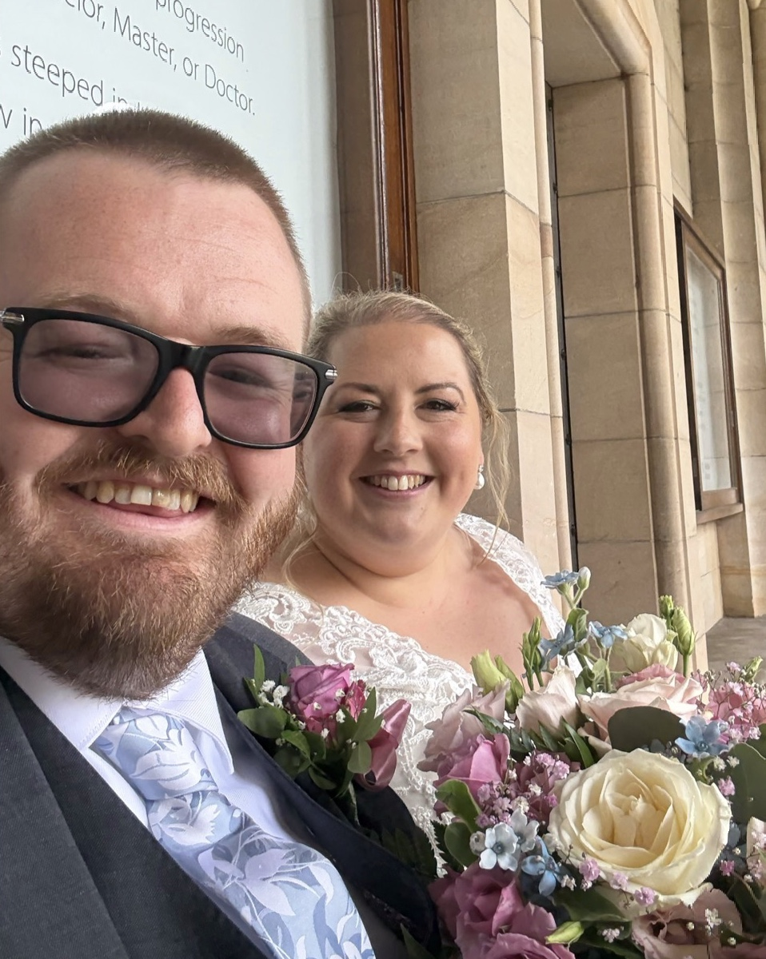
• Tom Coleman and Hollian Richardson who (finally!) got married on 25th July at St Salvator’s Chapel with a reception at the Verdant Works in Dundee.

• recently promoted staff: Collin Bleak and Ali Johnston to Professor, and Regina Bispo, Yoav Len, David Rees Jones and Hannah Worthington to Senior Lecturer
• Qihui Ming for winning the prize for best student poster in solar physics at the National Astronomy Meeting for his poster ‘Numerical modelling of turbulent antiparallel magnetic reconnection’. Also to St Andrews 2024 MMath graduate Conan Liptrott who won the best student talk prize for his talk ‘Multispacecraft observations of reconnection topologies and their role in the turbulent energy cascade’. Conan is now doing a PhD at Warwick.
• Deborah Kent and her course MT4561 ‘The History and Future of Data’ for receiving a 2025 Golden Dandelion Award for excellence in education for sustainable development at the University of St Andrews.

Welcome to …

• Kai Hugtenburg who joins us on 15th August as a lecturer in the Geometry group. Kai works on symplectic topology and mirror symmetry. He gained his PhD in Edinburgh in 2023 and has since been a postdoc at Lancaster University. He is a keen hill-runner.

Farewell to …

• Jack Reid and Daniel Johnson, whose contracts as Postdoctoral Research Assistants with the Solar and Magnetospheric Theory Group ended on 31st July. Jack came to St Andrews in 2013 as a BSc Mathematics student, and started a PhD with Alan Hood and Clare Parnell in 2016. Since 2020 he has worked as PDRA for the Group. Daniel joined the SMTG as a PDRA in January 2023 after completing his PhD at the University of Central Lancashire. We wish them all the best for the future – both will remain connected with the School as Honorary Research Fellows.

Visitors

• Lukas Klawuhn, a PhD student from the University of Paderborn, visited Sophie Huczynska from 28th July-7th August, funded by the DAAD (German Academic Exchange Service). They worked on a research project (also in collaboration with Maura Paterson at Birkbeck, University of London) and Lukas gave an Algebra and Combinatorics seminar entitled ‘Why I love association schemes - an introduction to Delsarte Theory’.
• Mark Demers from Fairfield University, Connecticut, USA, visited Mike Todd for two weeks to work on problems associated to recurrence and rate of escape of mass through holes. A non-mathematical escape occurred at St Fillan’s Cave in Pittenweem, where Mike, the Demers family and a nice German couple had to be set free after being locked in.

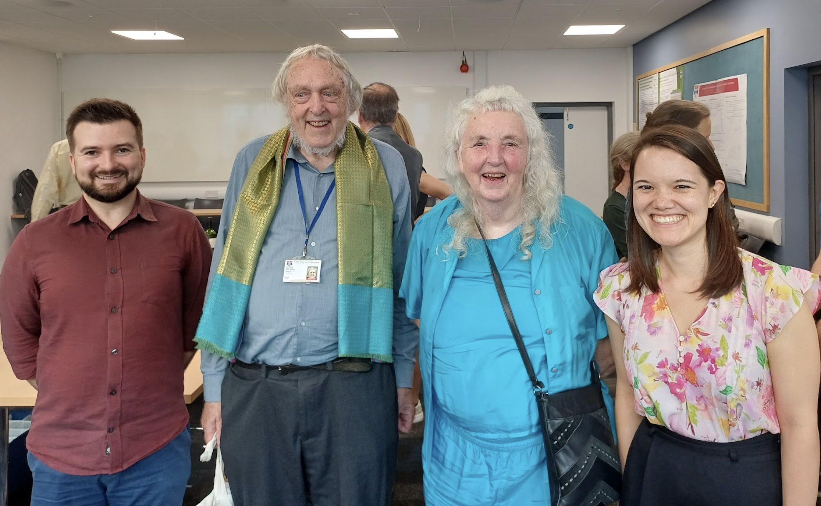
Conferences, Talks and Visits
Scott, Peter, Rosemary and Mia
• On August 12th the School hosted a very well-attended celebration of Peter Cameron and Rosemary Bailey’s time at St Andrews, featuring two talks by early career researchers who had worked closely with Rosemary and Peter. Mia Tackney gave a talk ‘From the ground up: Experiments in fields and in clinics’ and Scott Harper spoke on ‘Cameron counts and Cauchy numbers’. This was followed by a reception in the School and dinner at Zizzi.
• Peter Cameron and Rosemary Bailey attended MCW-XXX, the thirtieth Midsummer Combinatorics Workshop in Prague. Peter spoke on ‘A new look at twin reduction’, while Rosemary talked on ‘Semi-Latin squares and their extensions’.
• Josh Shelton attended the London Mathematical Society Undergraduate Summer School in Bath on 24-25th July and gave lectures on ‘Resummation of divergent series expansions and the Stokes phenomenon’.
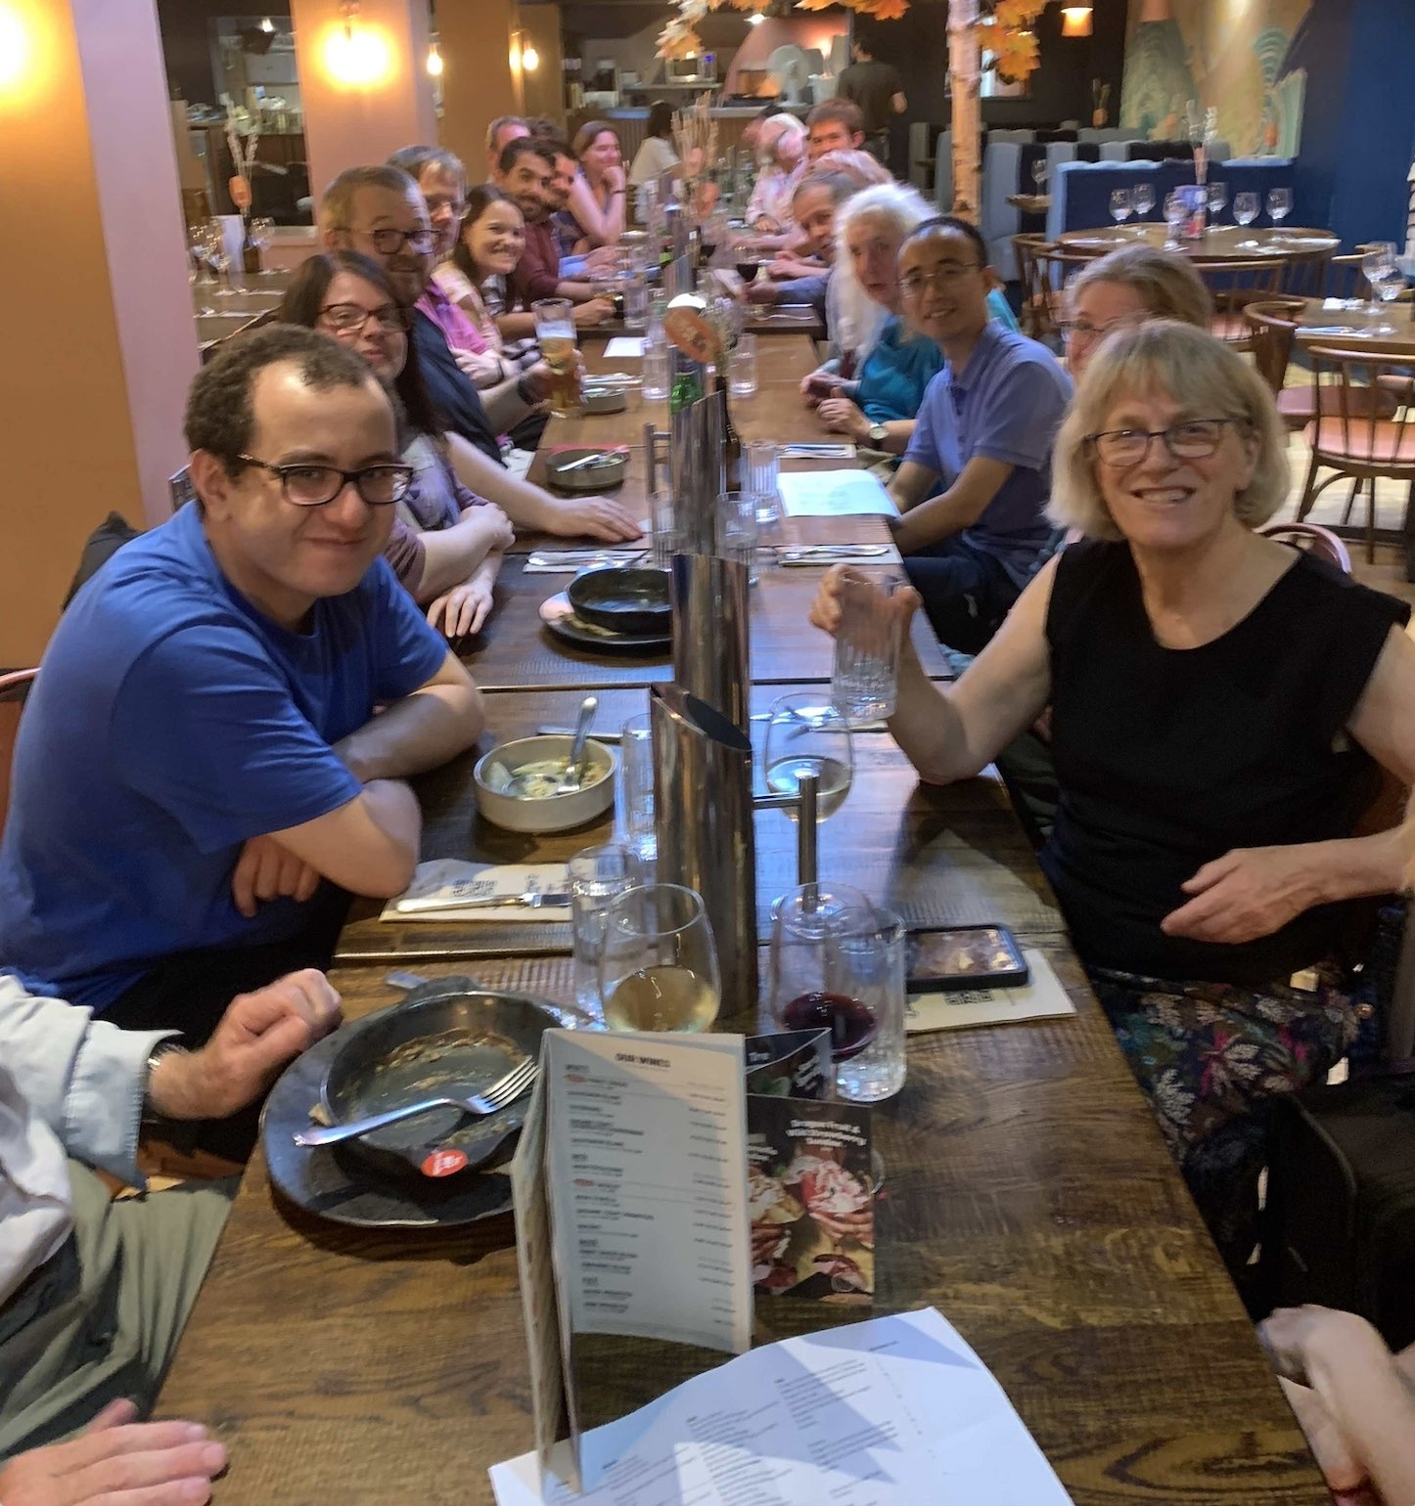
Celebration dinner at Zizzi
• Our CIRCA colleague Ruth Hoffman in Computer Science organised the Permutation Patterns 2025 conference, which was held in the Gateway Building in St Andrews from 7-11th July. Peter Cameron and Victoria Ironmonger attended and Victoria spoke on ‘The well quasi-order problem for combinatorial structures under the consecutive order’. Several former members of the School were present, including Vince Vatter and Christian Bean.
• Deborah Kent virtually presented a paper ‘Personal connections amid empires: 1899 British eclipse expeditions to French Guiana, Angola, and Trinidad’ for the Science and Empire Commission Symposium ‘Science and Empire Turns 30: Peoples, Places, Exchanges, and Circulation’ on 30th June at the 27th International Congress of History of Science and Technology, in Dunedin, New Zealand.

Other News

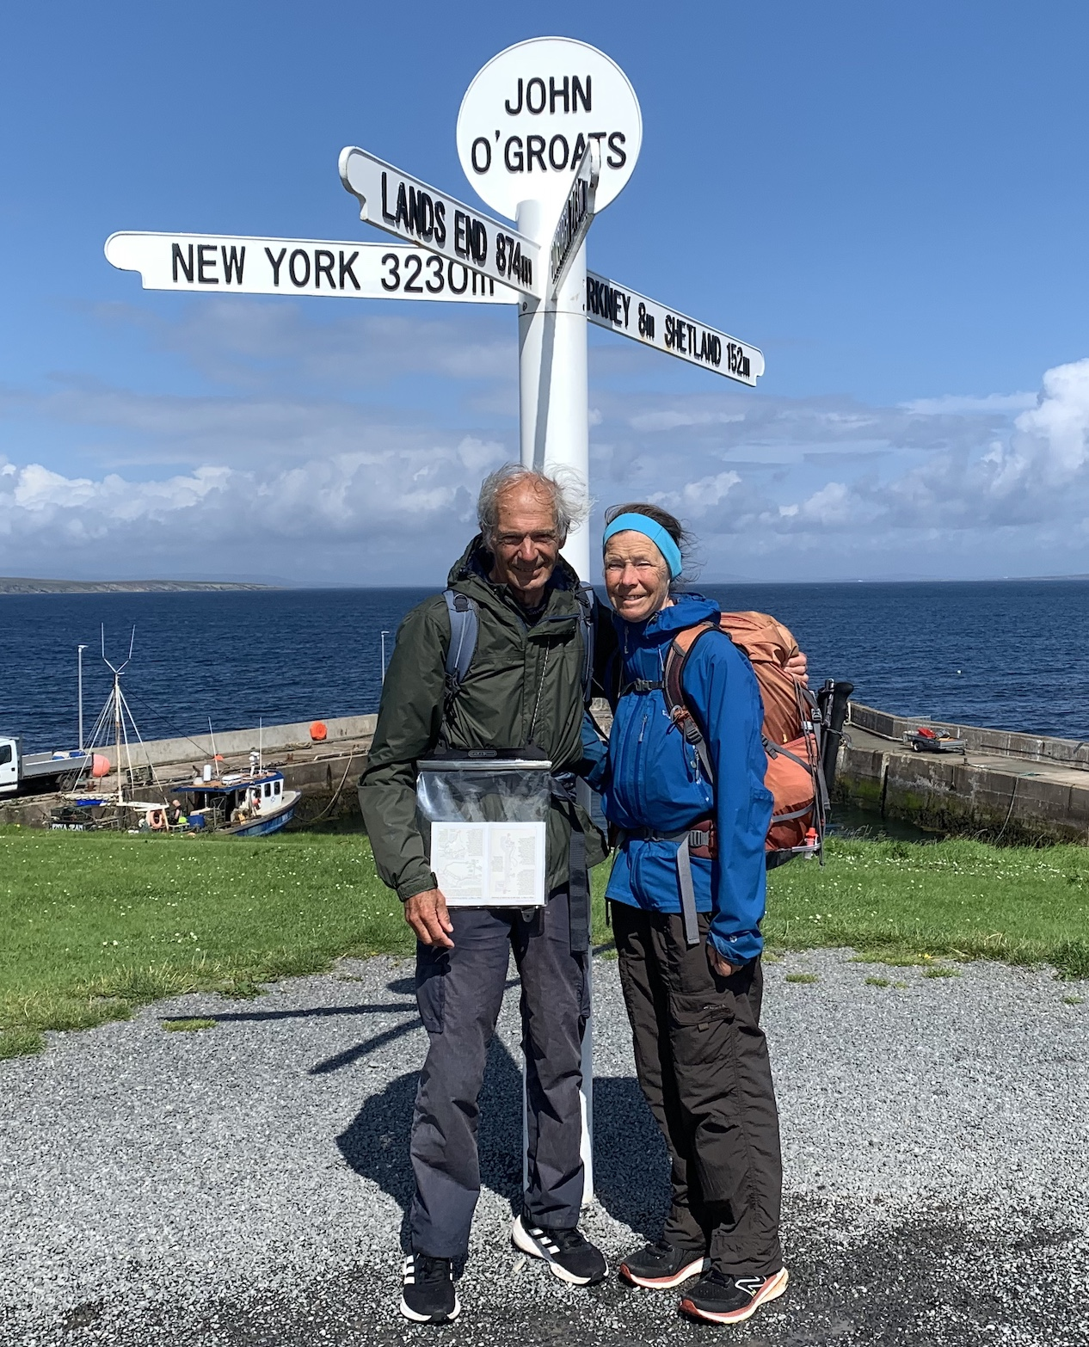
• Peter Cameron’s latest book, ADE: Patterns in Mathematics, co-authored with Pierre-Philippe Dechant (Leeds), Yang-Hui He (London Institute for Mathematical Sciences) and John McKay (Concordia), was published on 7th August in the London Mathematical Society Student Text series, ISBN 9781009335980 (paperback), 9781009335966 (hardback).
• Alex Russell and Tom Elsden were elected as council members for 3-year terms to the UK Solar Physics Council (UKSP) and the UK Magnetosphere Ionosphere Solar Terrestrial Council (MIST) respectively. These councils are responsible for managing UK wide engagement in these fields, for example, through conference organisation and dissemination of all field-relevant information.
• During the break Isobel and Kenneth Falconer walked from Land’s End to John o’ Groats along a route of about 1,015 miles (1,633km or 2,376,418 steps) on paths, tracks and lanes. This marked the 50th anniversary of the first time they completed such a walk.
Journey’s end

Next Issue

• The next edition of the School Newsletter will be circulated in September. Send items to maths-news@st-andrews.ac.uk at any time but a reminder will be sent out a week before the deadline.

