School of Mathematics and Statistics Newsletter

September 2025

Congratulations to ...
• Elisabeth Enerhaug for successfully defending her PhD thesis entitled ‘Identifying magnetohydrodynamic wave modes in the solar atmosphere’ on 12th August.
• Bromlyn Cameron who successfully defended her PhD thesis entitled ‘Abstract ping-pong systems in subgroups of Thompson’s groups’ on 14th August.
• Boyuan Zhao for successfully defending his PhD thesis entitled ‘Exponential mixing and almost sure limit theorems in dynamical systems’ on 10th September.
• all members of the School for contributing to our coming top for Mathematics and Statistics in the Guardian UK Universities 2026 rankings.

Welcome to …

• Steve Cantrell who joins the School as a Lecturer and who will be part of the Analysis group. Steve works around the intersection between ergodic theory and geometry. He received his PhD at Warwick University where he was subsequently a postdoc.
• Alison La Porta who has joined the Geometry group as a PDRA. Alison works in combinatorial rigidity theory and previously held a research fellowship at ICERM (Institute for Computational and Experimental Research in Mathematics) at Brown University in Providence, Rhode Island.
• Hamish Hay, a new PDRF in the Vortex Dynamics group. Hamish comes from the Department of Earth Sciences in the University of Oxford. He will be working with Daphné Lemasquerier and David Rees-Jones on numerical models of buoyancy-driven flows with phase change in icy moons.
• Roope Antilla who joins us as a PDRA in the Analysis group. Roope works on the geometry of fractal sets and measures and completed his PhD this summer at the University of Oulu, Finland.
• our new research students: Algebra and Combinatorics: Vishesh Lonial; Analysis: Fabian Despinoy, Yuyang Liu, Henry Phillips; Geometry: Georgios Kontogiannis; Medical Statistics: Nourah Alshahrani; Solar Theory: Liam Dolan; Statistical Ecology: Alessandro Araldi, William Ashton, David Sweeney; Statistical Methodology: Muslima Gazieva, Zhiwei (Jackie) Li; Vortex Dynamics: Madeleine Heideman; Co-tutelle students: Gordon Hannah and Miguel Martins who are currently starting at Lisbon University and will come to St Andrews next year.

Visitors
• Anita Pasotti, from the University of Brescia, Italy, visited Sophie Huczynska during the week of 25-29th August. They worked on a research project about Heffter Arrays.

Conferences, Talks and Visits
• The Statistics Division had an excellent representation at the Royal Statistical Society Annual Conference in Edinburgh from 1st-4th September. Ben Swallow was on the conference board and chaired multiple contributed sessions, gave a talk to the Young Statisticians Section on contributing to Discussion Paper meetings, was editor of the Discussion Paper plenary talk and a panel member of the session ‘Helping statisticians to thrive within the environmental, agricultural and biological sectors’. Saana Isojunno gave a talk and PhD student Rebecca Supple gave an invited talk in the ‘Causal mediation analysis’ session. Michail Papathomas chaired an invited session on ‘Advancements in divide-and-conquer approaches for Bayesian nonparametric models’, organised by him and Nicolò Margaritella, in which PhD student Harry (Hanyu) Wang gave a talk. Michail also contributed a talk. Nicolò Margaritella gave a talk and a rapid fire-talk and poster. Hannah Worthington organised and chaired an invited session on ‘Addressing the challenges for effective integration of AI and novel technologies in statistical ecology’, which brought together a panel of speakers from St Andrews, Cambridge, BioSS and Natural England. Recent MSc graduate Gordon Hannah presented a poster summarizing the results from his dissertation.
The conference ended with a very enjoyable dinner at the National Museum of Scotland, combined with the obligatory ceilidh, into which attendees of all levels threw themselves.
Titles of talks may be found at virtual.oxfordabstracts.com/event/40660/program
• From 8-11th September, Rosemary Bailey and Peter Cameron attended the XIII Working Seminar on Statistical Methods in Variety Testing held at COBORU (Centralny Ośrodek Badania Odmian Roślin Uprawnych) in Słupia Wielka in the utterly flat agricultural landscape of North-West Poland. Rosemary gave a talk on ‘Square array designs for trials with unreplicated test treatments and replicated controls’. The conference outing included a visit to the Institute of Plant Genetics of the Polish Academy of Sciences in Poznań. Its director, Paweł Krajewski, told Rosemary that he had met her when he visited John Gower at Rothamsted in the 1980s. He thanked her for helping him then both with the English writing and the mathematics in his paper!
• Peter Jupp attended virtually the workshop Advances in Directional Statistics in Luxembourg on 10-12th September. He presented a poster on ‘Testing uniformity of orbits of binary stars’.
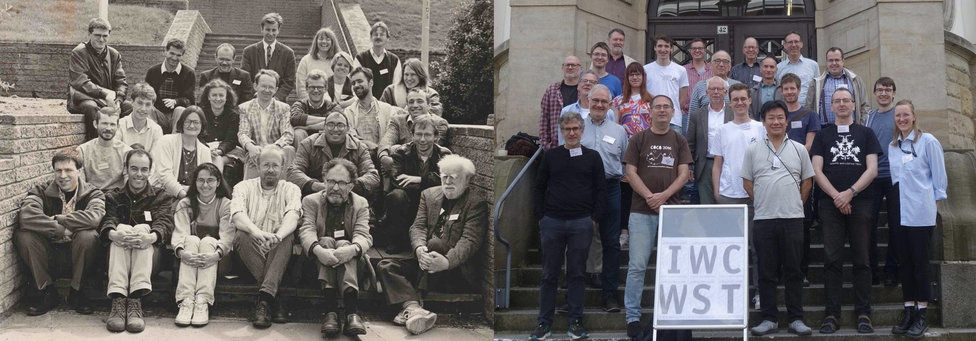
• Reinis Cirpons and James Mitchell visited Manfred Droste on 1st September at the University of Leipzig to work on homogenous structures and automata theory. They also attended the joint 14th International Workshop on Confluence and 20th International Workshop on Termination from 2nd-4th September at the Leipzig University of Applied Sciences. Reinis gave a talk titled ‘Off with the head! Termination provers and the word problem for 1-relation monoids’. The first International Workshop on Termination was held in St Andrews in 1993, and the present workshop featured a small exhibit on its history.
Participants at the 1st and 20th International Workshop on Termination in 1993 and 2025
• Tom Coleman attended CETL-MSOR 2025 (Centre for Excellence in Teaching and Learning - Mathematics, Statistics and Operational Research) at the University of Liverpool on 4th-5th September, where he gave a talk ‘Involving students in the creation of accessible mathematics and statistics resources’.
• On 8-9th September Isobel Falconer organised a 2-day workshop at the University of Manchester for the History for Diversity in Mathematics workshop on the topic of ‘Creating and Curating Resources’. The workshop showcased the online database of resources that the network is beginning to develop, and compared this with a parallel project on ‘Unrecognised Pioneers of Computing’ at the Open University. One of the local organisers was Gemma Crowe, one of our former undergraduates.
• On 16th September Ana De Orellana visited the University of Edinburgh to work with Itamar Oliveira, a research fellow at the University of Birmingham.
• Thibault Poiret and Violeta Lopez attended the Tropical Mathematics and its Applications conference in Durham on 11-12th August, where Thibault spoke on ‘Tropicalizing some natural covers of the space of curves’ and Violeta talked on ‘A new Brill-Noether general tropical curve’.
• Violeta Lopez attended the 21st meeting of the Applied Algebra and Geometry Network in Edinburgh on 21st August. There she met Sarah Rees, who recently joined in the celebration of Peter Cameron and Rosemary Bailey’s time at St Andrews. Sarah sends her regards to everyone.
• Joe Edwards and James Mitchell travelled over 2,000 km by train to the University of Primorska in Slovenia to attend the GAP Days meeting from 25-29th August. On arrival they were joined by former PhD student Wilf Wilson. James gave a minicourse on the Digraphs package, with help from Joe and Wilf.
• From 4-5th September, Bromlyn Cameron, Jung Won Cho, Yayi Zhu and Faith Hurst attended PiFORUM25, the Piscopia Initiative Annual Conference, at Queen Mary University of London. Bromlyn gave a talk on ‘Transition chains in Thompson’s group F’, Cho spoke on ‘Introduction to inverse semigroups and free inverse semigroups’, and Faith gave a joint talk with Eleanor Milburn (Warwick) on ‘The quantum group U_{q}(sl(2|1)) and its representations’.
• Bromlyn Cameron attended the Mathematics Communication Training Workshop, organised by the Isaac Newton Institute and Newton Gateway, hosted at the University of Glasgow from 2nd-3rd September.
• Nik Ruskuc gave an invited lecture ‘Automorphism groups of filtered Boolean powers’ at the Algebras and Algorithms special session of the AMS 2025 Fall Western Sectional Meeting at the University of Denver on 24th August. Nik continued with a research visit to Peter Mayr from 25th August-17th September at the Colorado University at Boulder where they are completing two papers on ample generics and Ramsey properties in Boolean powers. During the visit Nik gave a talk entitled ‘(Congruence) diameter of semigroups’ at the Panglobal Algebra and Logic Seminar (PALS).
• David Rees Jones, Jean Reinaud and Dan Lucas attended the European Fluid Dynamics Conference in Dublin 25th-29th August, presenting talks on ‘Modelling melt pond drainage through porous, reactive sea ice’, ‘Quasigeostrophic vortex merger over bathymetry’ and ‘Obtaining dynamically relevant recurrent flows via triads’ respectively.
• Tom Elsden attended the IAGA 2025 (International Association of Geomagnetism and Aeronomy) Scientific Meeting in Lisbon, from 31st August-5th September, and gave a talk entitled ‘Theory and modeling of large scale plasmapause surface waves’.
• Nikos Sfakianakis attended the first UK Mathematical Biology Conference ukmathbioconference.github.io that took place on 4-5th September at the University of Birmingham, and gave a talk titled ‘A multiorgan and genuinely hybrid 3D cancer metastasis model over virtual patient framework’.

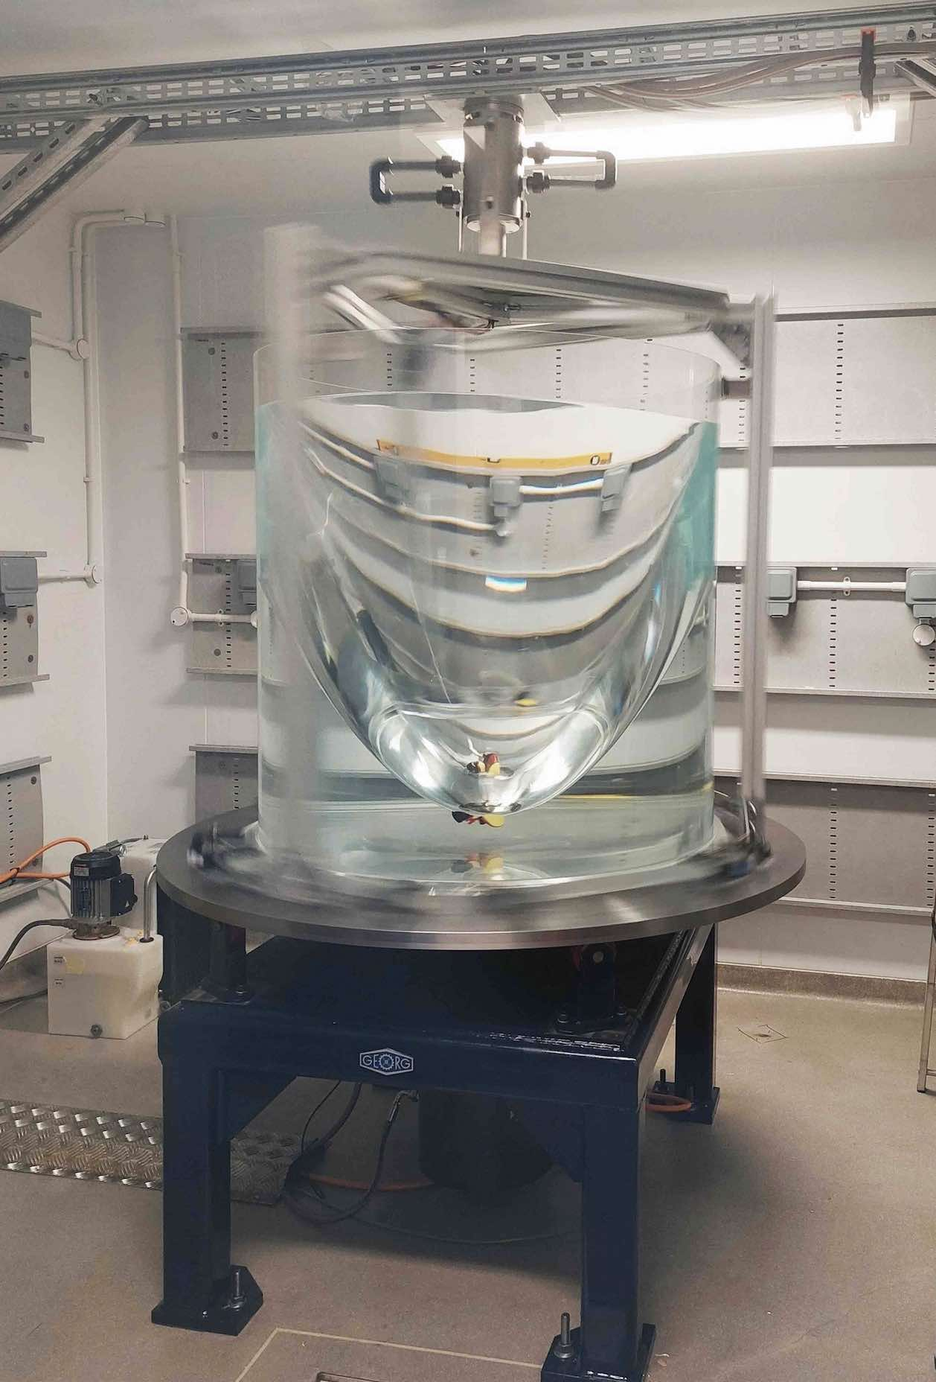
Other News
• This summer saw the delivery and installation of a major new facility for Daphné Lemasquerier’s Future Leaders Fellowship project: a bespoke, high-precision rotating table. The rig can spin at up to 200 revolutions per minute with a 1-ton load. It is now up and running in the Aquarium Facility at the Scottish Oceans Institute. The photo shows it in action at 80 rpm carrying a tank filled with 350 litres of water. If you have any spare rubber ducks at home, we’d be very happy to give them a new scientific purpose!
• A paper on ‘Solar flare ion temperatures’, led by Alex Russell, has generated media coverage including by NPR, Hawaii Public Radio, the Smithsonian Magazine, Newsweek and BBC Newsround. The new research, published in the Astrophysical Journal Letters, argues that solar flare ions are up to 6.5 times hotter than previously believed, setting new temperature records in the solar corona. Daphné’s new toy!
• On the morning of Tuesday 9th September, you might have noticed groups of new undergraduate students exploring the Mathematical Institute during a scavenger hunt that took them up and down the stairs while they familiarised themselves with the building. On Wednesday 10th staff and undergraduate students met for the first coffee and cake of the academic year. A quiz tested their knowledge of Scotland, science, food and countries and flags around the world. The winning team was The Flapjacks (all students), with 36 correct answers out of 50. The events were organised by Stefania Lisai as Student Wellbeing Officer, with many thanks to Valerie and Evlyn for the caffeine and sugar support, and all staff members who took part.
• The Statistics Division held a summer BBQ hosted by a local start-up company on the University’s Eden Campus: Eden Valley Prawns edenvalleyprawns.com. The company are pioneering zero-waste prawn farming and gave a really interesting tour of their demonstrating facility and also donated delicious prawns to the BBQ! If anyone is interested in purchasing king prawns and supporting a worthy new business with links to the University (they started life in the Scottish Oceans Institute using their experimental tanks) they can be contacted at info@edenvalleyprawns.com. The Division is also grateful to PhD student Yan Ru Choo for acting as pit-master – he submitted his thesis that morning so it was a double celebration!

Next Issue
• The next edition of the School Newsletter will be circulated in October. Items may be sent to maths-news@st-andrews.ac.uk at any time but a reminder will be sent out a week before the deadline.

