School of Mathematics and Statistics Newsletter

October 2025

Congratulations to ...
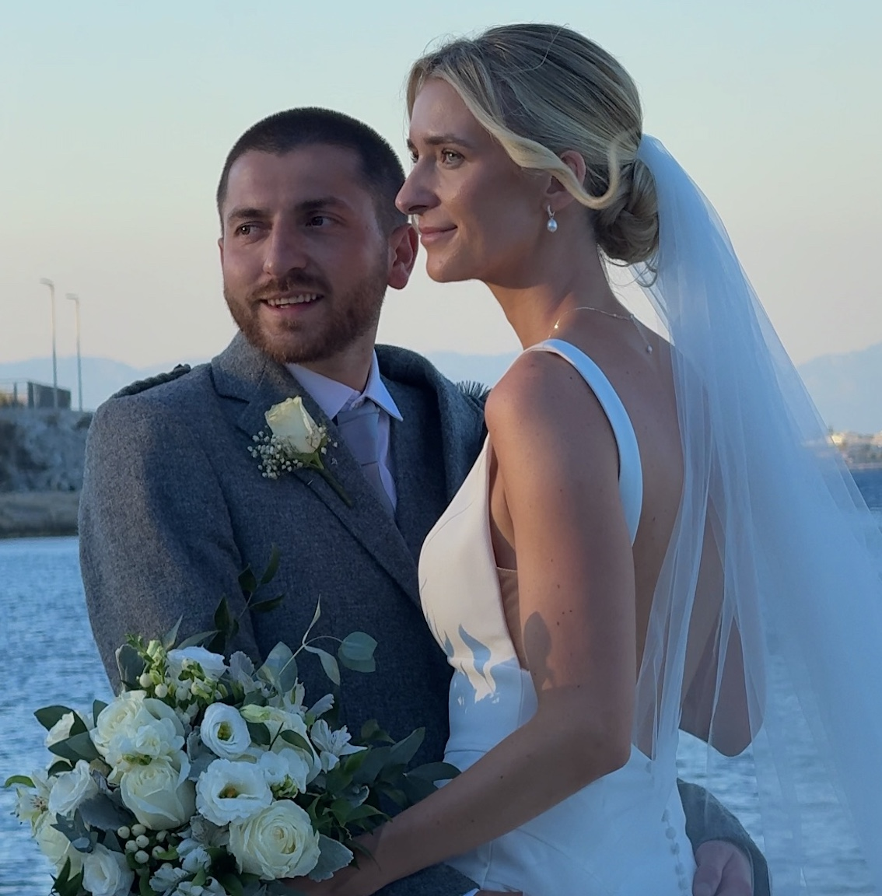
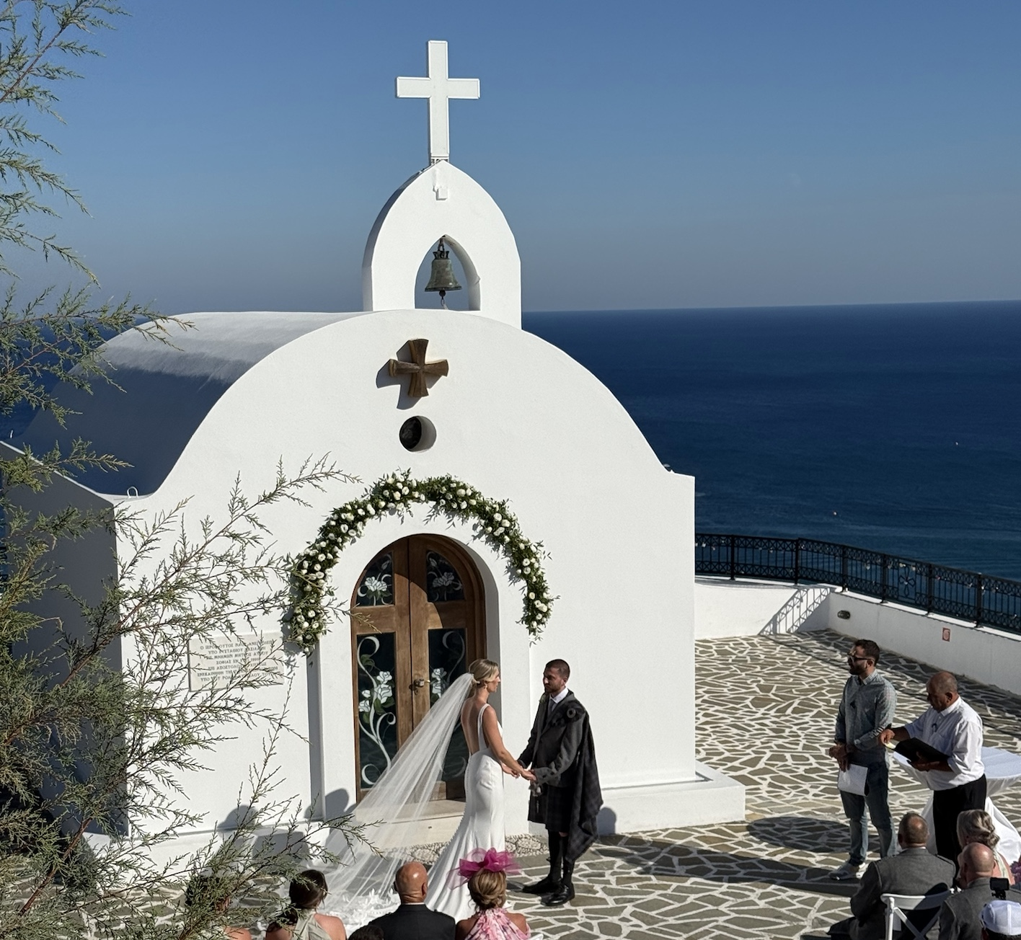
• Danielle Watson (our Research Centres and Institutes Administrator) and Si Beech on their wedding on the island of Rhodes.

Welcome to …

• Hemanthi Miriyala who joined the Solar and Magnetospheric Theory Group as a Postdoctoral Research Fellow at the beginning of September to work with Ineke De Moortel.
• Thomas Breitburd and Maxwell Jackson, new PhD students who have joined the new NCAS (National Centre for Atmospheric Science) St Andrews climate and machine learning group. Thomas will develop machine learning applications for understanding compound extreme events and Maxwell will use ML to unravel the complexities of cross-scale interactions in the climate system.

Conferences, Talks and Visits
• Natalia Jurga and Mike Todd organised a meeting of the Scottish Dynamics Network in St Andrews on 19th September. There were three sessions with speakers from St Andrews, Glasgow and Heriot Watt. The local speakers were Steve Cantrell, Natalia Jurga, Saeed Shaabanian and Mike Todd. Afterwards attendees adjourned to the pub and dinner.
• Tom Coleman gave an invited talk at the Technology Enhanced Mathematics Sciences Education (TEMSE) seminar (jointly organised by the University of Edinburgh and Heriot-Watt University) at the Bayes Centre in Edinburgh, on ‘Involving students in maths and stats resource creation’.

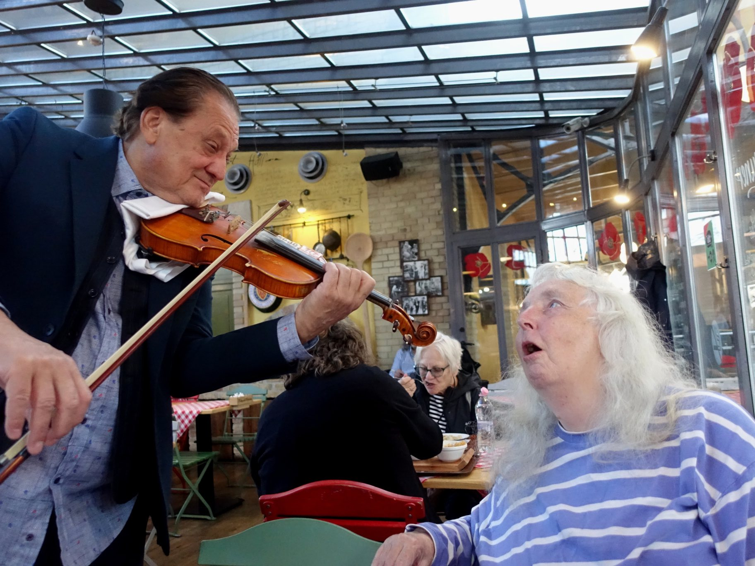
• Rosemary Bailey and Peter Cameron were in Budapest for the Group Theory Day at the Alfred Rényi Institute to mark the 70th birthday of Péter Pál Pálfy (P cubed to his colleagues and friends). Péter was one of Peter’s earliest coauthors from more than 40 years ago and a former director of the Institute. After a morning of talks by P cubed’s students, Peter gave the closing talk of the day, on ‘Inverse Group Theory’.
Rosemary being serenaded at the Fakanái restaurant in Budapest with her request of Auld Lang Syne
• From 17-19th September, Rosemary Bailey and Peter Cameron attended the EUCARPIA Section Biometrics in Plant Breeding meeting at the Royal College of Physicians in Edinburgh. Rosemary gave an invited talk ‘Designs with more than one blocking system: the conflict between valid randomization and latinization’. One of the organizers, Daniel Tolhurst, who is based at the Roslin Institute, told Rosemary that he had attended the short course on ‘Multiphase experiments: from design to analysis’ which she gave at a meeting of the Biometric Society in Hobart in 2015.
• Isobel Falconer attended the Historiography of Mathematical Symbolism conference in Edinburgh from 15-19th September. This brought together historians of mathematics from around the world and of all career stages. Isobel was the official commentator on the paper, ‘Historiography of Mathematical Notations by Cambridge’s Algebraists (1820-1845)’ by Marie-José Durand-Richard (Paris VIII).
• From 8-12th September, Lindesay Scott-Hayward and Saana Isojunno travelled to Montpellier for the 8th Conference on Wind Energy and Wildlife Impacts. Lindesay was invited to talk at the preconference workshop on bird displacement and gave a talk in the main conference on ‘Tracking 25 years of changes in seabird distribution and abundance in response to the successive development of three wind farms in Danish waters’. Saana presented a poster on ‘Quantifying sensitivity: a framework to map relative risk to seabirds from future offshore wind energy developments in Danish waters’. The conference had over 1000 attendees and included an unexpected ‘lock-in’ at the venue owing to protests!
• On 23rd September, Lindesay Scott-Hayward gave a keynote talk ‘From data to decisions: Statistics in conservation and impact assessment’ at the launch for the Institute of Mathematics and its Applications first special interest group on Climate, Environment and Sustainability.

Future Events
• On Tuesday 28th October, the School of Maths and Stats will host a Wear it Pink day in support of the charity Breast Cancer Now. All members of the community are encouraged to wear an item of pink clothing to help raise awareness of breast cancer. Additionally, in collaboration with the St Andrews Oncology Society, there will be a bake sale in the foyer of the Medical Sciences Building from 11am-3pm. To learn more about the event, including how to donate to the cause, visit www.justgiving.com/team/usta-north-haugh.

Outreach
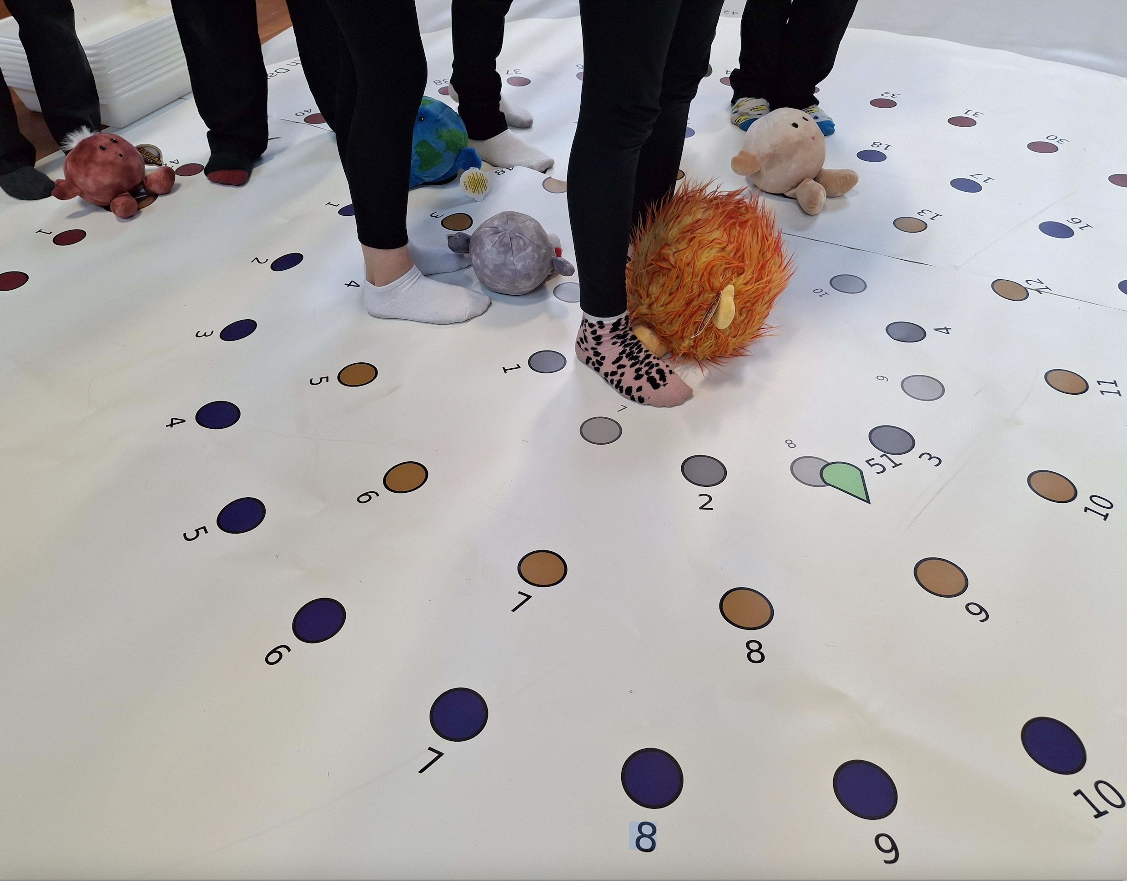
• Deborah Kent has collaborated with the School of Earth and Environmental Sciences GeoBus Team on solar system outreach using the STFC-funded interactive Human Orrery she developed for solar-eclipse events in the zone of totality in 2024. The Orrery facilitates solar system workshops for teacher development in St Andrews and has also been used at primary schools in Glenrothes and Cupar. In late September, the Orrery and Celestial Buddies (pictured) went to Islay, Argyll & Bute for P6 and P7 workshops. In the coming months, it will be used by P5, P5, P7 pupils at Oxgang Primary School
in Kirkintilloch, East Dunbartonshire and The Orrery in action
for teacher training courses in Glenrothes.
• To mark Maths Week Scotland, Jon Fraser and Kenneth Falconer visited St Leonards School on 24th September where they entertained S5 and S6 pupils with talks on mathematics.

Other News
• Mike Todd has been awarded an EPSRC Mathematical Sciences Small Grant for £60k for the project ‘Random pair distributions’.
• James Mitchell has become Chair of the GAP Council. GAP (Groups, Algorithms, Programs) is a system for computational discrete algebra and computational group theory. It provides a programming language and a library of thousands of functions implementing algebraic algorithms written in the GAP language as well as large data libraries of algebraic objects. The GAP Council consists of about 18 senior mathematicians and computer scientists who provide broad policy advice for the future development of GAP.
• The NCAS (National Centre for Atmospheric Science) climate and machine learning group has started two weekly meetings – a learning group with in-depth discussion of AI methods (11am Monday, Maths Institute tutorial room 1C) and a reading group / paper discussion (11am Wednesday, Bute building, room C5).

Future Events
• On Tuesday 28th October, the School of Maths and Stats will host a Wear it Pink day in support of the charity Breast Cancer Now. All members of the community are encouraged to wear an item of pink clothing to help raise awareness of breast cancer. Additionally, in collaboration with the St Andrews Oncology Society, there will be a bake sale in the foyer of the Medical Sciences Building from 11am-3pm. To learn more about the event, including how to donate to the cause, visit www.justgiving.com/team/usta-north-haugh

Next Issue
• The next edition of the School Newsletter will be circulated in November. Items may be sent to maths-news@st-andrews.ac.uk at any time but a reminder will be sent out a week before the deadline.

