School of Mathematics and Statistics Newsletter
October 2024

Congratulations to ...
• Scott Harper who was awarded the Reinhold Baer Prize 2024 at the AGTA (Advances in Group Theory and Applications) Workshop – Reinhold Baer Prize in Napoli, a meeting dedicated specifically to the prize which is awarded biennially to a young researcher working in group theory based on a paper or thesis written in the previous two years. Scott’s award was for ‘The maximal size of a minimal generating set’, published in Forum of Mathematics, Sigma last year. Reinhold Baer (1902-1979) was a German algebraist who worked in many areas of pure mathematics but especially group theory.
• Georgios Chouliaras on successfully defending his thesis entitled ‘The effects of partial ionization on flux emergence and solar eruptive events’ on 13th September.
Welcome to ...
• Jeremy Tyson, from the University of Illinois at Urbana-Champaign, who is visiting for three months from 3rd October to work with the Analysis group.
Farewell to ...
• Shayo Olukoya who will be leaving St Andrews at the end of October for a position with the University of Aberdeen for the rest of his EPSRC Postdoctoral Fellowship. He remains open to joint projects if you have connections to his work, so please contact him!
Visitors
• Victoria Gould from York is visiting Nik Ruskuc from 14-18th October.
• Steve Senger from Missouri is visiting Jon Fraser and the Analysis group from 14-18th October.
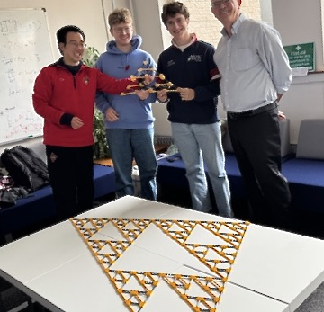
• Victor Donnay, from Bryn Mawr College, Pennsylvania, visited from 7-11th October to give a seminar, interact with the Analysis group, and play golf. The first part of his seminar involved the audience clicking together K’NEX pieces to form a Sierpiński triangle with a base of about 4 feet. This pales into insignificance compared with the one Victor coordinated as a community project in his university which used 89,000 pieces and filled most of their football pitch.
The K’NEX Sierpiński triangle
constructed in the Analysis seminar
Conferences, Talks and Visits

• In late September, Rosemary Bailey and Peter Cameron visited the University of Calgary. Peter gave the 19th Louise and Richard Guy Lecture, on ‘Sudoku and Mathematics’, to a nearly full audience in the University ballroom. Richard died in 2020 aged 103, having been an active member of the department at Calgary for half his life, coming to his office almost every weekday until shortly before his death. Rosemary gave a Distinguished Colloquium on ‘Design and analysis of scientific experiments’, touching on the misunderstandings that can occur in conversations between statisticians and scientists, to a lively audience, and also gave a keynote lecture to a meeting of Alberta statisticians on ‘Design of two-phase experiments’. There was time for a visit to Banff (including riding the gondola to the summit of Sulphur Mountain) and to Drumheller, the ‘dinosaur city’ in the Alberta badlands.
• From 7-9th October, Rosemary Bailey and Peter Cameron attended a conference to celebrate the 30th anniversary of the arrival of Dugald Macpherson (one of Peter's earliest doctoral students) at the University of Leeds. Peter gave the closing talk on ‘Filters, topologies and permutation groups’. The conference motto was ‘Touch not the structure bot an automorphism group’, based on that of Clan Macpherson ‘Touch not the cat bot a glove’.
• On 3rd October, Peter Cameron delivered a talk on ‘Graphs defined on groups’ at a 5-Day Online Faculty Development Programme on Advances in Graph Theory and Linear Algebra, which will be organized by VIT-AP University, Andhra Pradesh, India.
• From 10-13th September, Coen del Valle, Scott Harper, Colva Roney-Dougal and Peiran Wu attended the conference Topics in Group Theory at the University of Padova to celebrate the 2⁶th birthday of Andrea Lucchini (postponed from a 60th birthday conference due to be held in 2020). Coen spoke on ‘The base size of the symmetric group acting on subsets’, Scott on ‘Is a finite group ever the union of conjugates of two equal-sized subgroups?’ and Colva on ‘The number and nature of subgroups of the symmetric group’.
• From 16-20th September, Scott Harper visited Pablo Spiga at the University of Milano-Bicocca to work on a connection between permutation groups and algebraic number theory. Then from 7-8th October he attended the AGTA Workshop – Reinhold Baer Prize in Napoli where he spoke on ‘Minimal generating sets for finite groups’ – see also under ‘Congratulations’ above.
• Colva Roney-Dougal visited Andrea Lucchini, Daniele Nemmi and Eloisa Detomi at the University of Padova for two weeks to work on projects about minimal generating sets of finite groups and on the length of subgroup chains in finite groups.
• Fractal Geometry and Stochastics 7 took place in Chemnitz, Saxony, Germany from 23rd-27th September. Kenneth Falconer, Tianyi Feng and Ana de Orellana gave talks and six former members of the School also attended the conference, including Steffen Winter, one of the main organisers. This is the 7th meeting in the series, the first of which was in 1994 – Kenneth is one of just four people to have attended them all.
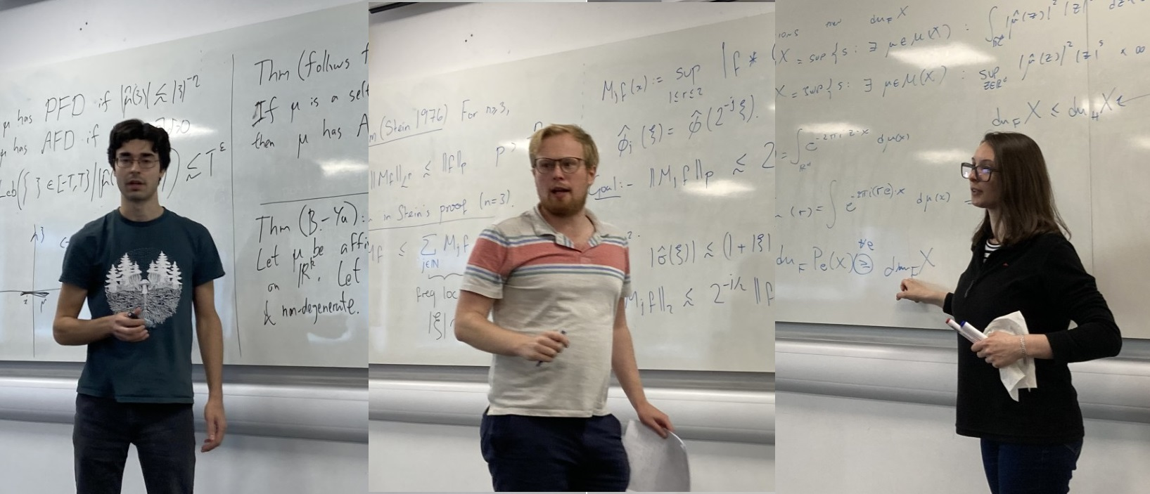
Amlan, Jon H and Ana making good use of whiteboards at the Afternoon Workshop
• About 20 people attended an Afternoon Workshop on Fourier Analysis, Fractals, and Finite Fields on 18th September, organized in St Andrews by Jon Fraser. The speakers were former School members Amlan Banaji (Loughborough), Jon Hickman (Edinburgh) and Han Yu (Warwick), current School members Jon Fraser, Ana de Orellana and Firdavs Rakhmonov, together with Hrit Roy (Edinburgh).
• On 30th September Ana de Orellana gave an Analysis Seminar at the University of Edinburgh, the talk was entitled ‘Dimension interpolation and exceptional set estimates’.
• Daphné Lemasquerier attended the UKRI FLF (Future Leaders Fellowship) starting meeting for the 8th cohort held in Cardiff on 2nd-3rd October. This was a nice opportunity to connect with fellows in other fields and/or geographically close and ask questions about the management of the award! Daphné also gave a talk for the Planetary Seminar series of the School of Physics and Astronomy at the University of Leicester on 9th October where she met Leigh Fletcher and his group. Leigh is a project partner on Daphné's FLF and will help bridge the gap between models and ground-based or space-based observations of giant planets.
• Alex Stewart gave a talk at Lund University in Sweden about the (potential) role of mathematical models in political science, and a talk at the Complexity Science Hub in Vienna about the evolution of belief.
• Ursula Martin has been touring. She spoke, alongside Principal Dame Sally Mapstone, at an event in Oxford celebrating fifty years since women were first admitted to Oxford's former mens’ colleges (albeit two years behind Cambridge). She then spoke at the XXVI Deutscher Kongress für Philosophie in Münster, Germany, part of a panel ‘From analogue to digital’, organised by the DGPhil-AG Frauen in der Geschichte der Philosophie und der Internationalen Assoziation der Philosophinnen. Ursula also gave the annual Caledonian Lecture at London’s Caledonian Club, discussing how Mary Somerville’s illustrious career was shaped by her time in Fife, Edinburgh and the Borders.
• Sophie Huczynska attended an in-person committee meeting of the Ethics Committee of the European Mathematical Society in Prague, on 13-14th September.
• To celebrate Maths Week Scotland, Isobel Falconer ran two ‘show and tell’ sessions in Special Collections that showed off the richness of our collections for the history of St Andrews' engagement with mathematics from 1500-1900. The sessions were full, attracting the public, tourists, and university members from first year students to emeritus staff.

Other News
• During Orientation week, many teams of students and staff took part in a quiz during the Meet Your Lecturers social event. The teams were tested on their knowledge of Scotland, Maths and Science, and World Geography and History! Although the competition was fierce, the team ‘Mathematical Munchkins’ (one of the few teams without a member of staff!) triumphed with a score of 42/50. Thanks Stefania for organizing this.
• Many thanks to Jonah Klowss, Stefania Lisai, and Feyisayo Olukoya (Shayo), who led a team of STEP students in developing a useful set of resources on ‘Decolonising the mathematics curriculum’, which is now available from the School website (under EDI resources) or at decolonisingmaths.wordpress.com
Next Issue
• The next edition of the School Newsletter will be circulated in November. Items may be sent to maths-news@st-andrews.ac.uk at any time but a reminder will be sent out a week before the deadline.

