School of Mathematics and Statistics Newsletter

March 2025

Welcome to ...
• Jeff Hicks who joins us as a Lecturer in Mathematics in the newly formed Geometry research group. He will spend his first five years with us on an EPSRC Open Fellowship. Jeff took his PhD at the University of California, Berkeley and then held research positions at ETH Zurich, Cambridge and Edinburgh before coming to St Andrews.

Visitors
• Pieter Allaart, on sabbatical leave from the University of North Texas, is visiting the Analysis group from 24th February-30th March. His partner and colleague Kiko Kawamura is also visiting from 10-14th March.
• Antti Käenmäki from Helsinki is visiting the Analysis group from 11-14th March and gave an analysis seminar.

Conferences, Talks and Visits
• On 4th March, Sophie Huczynska gave an online talk in the Discrete Mathematics Seminar series co-organized by the Universities of Brescia and Modena e Reggio Emilia, Italy.
• On 12th February, Peter Cameron attended the second Simon Norton Memorial Lecture, delivered by Professor Leonard Soicher at the London Institute of Mathematical Sciences, having himself given the first lecture in the series last year. The lectures were held in what was Michael Faraday’s drawing room at the Royal Institution in London.
• Victoria Ironmonger gave an online talk on ‘Well quasi-order under the consecutive order: equivalence relations and permutations’ at the Open University Discrete Maths Seminar on 26th February. She also visited former St Andrean Robert Brignall at the Open University from 5-7th March.
• Jon Fraser gave an online keynote talk on ‘Fourier dimension of the Brownian graph’ on 31st January at the Workshop on Fractals: Geometry, Analysis, Algebra, Numerics and Applications at the Indian Institute of Information Technology (IIIT), Allahabad, India. He also spoke on ‘L² restriction estimates from the Fourier spectrum’ on 12th February at the Maxwell Institute Analysis Seminar in Edinburgh.
• An De Orellana visited the university of Bristol from 5-7th March, where she gave a talk titled ‘Fourier restriction for multifractals’.
• Joe Edwards travelled to the Isaac Newton Institute in Cambridge for the Graduate Training Workshop for the Mathematical Sciences held from 10-14th February. The workshop covered topics such as science communication skills, industry engagement and knowledge exchange. When not attending talks, Joe explored some of the colleges, and met with a former St Andrean Tom Conti-Leslie as well as encountering three St Andrews staff members.
• Lindesay Scott-Hayward participated in the ScotMER (Scottish Marine Energy Research Programme) symposium on 25-28th March. The hybrid event drew over 1,000 attendees from every continent except Antarctica! One day of the symposium was held in person, in Stirling, marking the first in-person gathering since COVID. It was a refreshing opportunity to reconnect with colleagues face-to-face after such a long period of virtual interactions.
• Irene Kyza gave an invited talk in the Minisymposium ‘Numerical Methods for Nonlinear and Nonlocal Transient Phenomena’ which was part of the Conference on Mathematics of Wave Phenomena that took place in Karlsruhe, Germany, from 24-28th February.
• Tom Elsden gave the Solar and Space Physics Seminar at Northumbria University on 5th March, where he talked about the theory and modelling of large scale plasmapause surface waves. The Northumbria group includes several former members of the solar group, including Patrick Antolin, Steph Yardley and James McLaughlin.
• On 14th February, Duncan Mackay presented a talk, ‘Impact of an L5 magnetograph on global non-potential modelling’ at the Royal Astronomical Society (RAS) Specialist Discussion meeting in London on Space Weather Science from the Fifth Lagrange Point.
• As a Simons Foundation Fellow at the Isaac Newton Institute, Deborah Kent delivered the final invited lecture in the opening workshop Modern History of Mathematics: Emerging Themes on 24th January. Her talk ‘A stone to be seen: Kwanlin Dün and the 1869 US total solar eclipse expedition’, raised questions about incorporating indigenous perspectives in narratives of 19th-century mathematical sciences. Then on 27th January she gave an invited presentation at the INI-ICMS Correspondents Day Meeting on the theme of ‘Inclusion in the UK mathematical infrastructure: resources and approaches from history of mathematics’.
• As part of the Isaac Newton Institute Modern History of Mathematics Programme, Isobel Falconer gave a seminar on 20th February, entitled ‘Almanacks as a household enterprise, 1600-1750’. Then on 5th March she gave a talk to the Strathmartine Centre in St Andrews ‘From Neptune to St Andrews: John Couch Adams, Regius Professor of Mathematics’. The Strathmartine Centre is affiliated to the University but exists to support independent scholars working on topics in Scottish history.
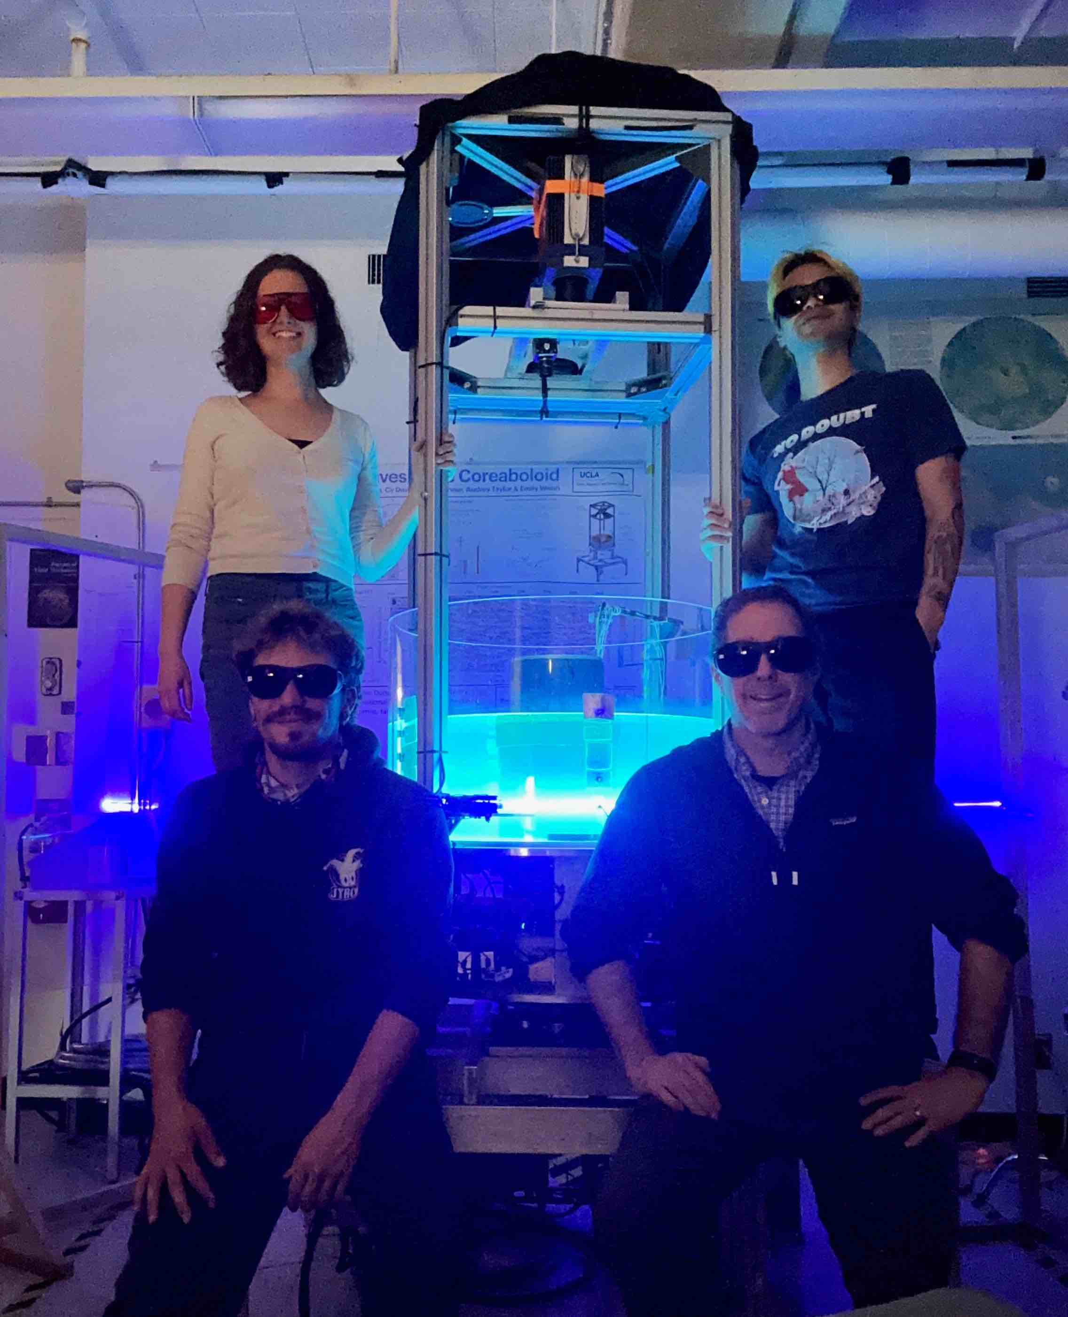
• After IPAM’s workshop in January, Daphné Lemasquerier remained in Los Angeles for a four week collaborative research project at Spinlab, UCLA. The newly formed Topoboloid (topography+paraboloid) team ran lab experiments on turbulent, rapidly-rotating convection interacting with a localised topography. During Daphné’s visit, the rotating table hit 72 revolutions per minute, the egg prices reached $11 for a dozen, and thermometers hit 30˚C in mid-February. Not sure which of these figures is the most impressive!
• St Andrews was well represented at the British Society for the History of Mathematics Research in Progress meeting on 22nd February. Kate Hindle and Megan Briers (former undergraduate, now at MPIWG in Berlin) gave talks on their PhD work, Daphne and colleagues at Spinlab
Andrew Halyburton (final year MMath student) and
David Thorsteinsson (former MMath student, now at KU Leuven), joint winners of the BSHM undergraduate essay prize last year, presented the topics of their essays, and Takaaki Iwai presented a joint poster with Alisa Senses about their work on the history of fisheries modelling for the VIP History, Mathematics and the Public module. Deborah Kent and Isobel Falconer also attended the meeting.

Next Issue
• The next edition of the School Newsletter will be circulated in April. Items may be sent to maths-news@st-andrews.ac.uk at any time but a reminder will be sent out a week before the deadline.

