School of Mathematics and Statistics Newsletter

July 2025

Congratulations to ...
• Ursula Martin, Honorary Professor in our School, who was appointed a Dame Commander of the Most Excellent Order of the British Empire in the King’s Birthday Honours for services to science and education. Ursula was Professor of Computer Science (just the second female professor in the University) from 1992-2002; for most of that time there was a single School of Mathematical and Computational Sciences. She is a highly distinguished mathematician and computer scientist and has also contributed to the history of these subjects. She has been a pioneering advocate for women in maths and computer science and has made numerous important contributions to national and international policy.
• Coen del Valle who on 23rd June successfully defended his PhD thesis entitled ‘All about the base’.
• Perian Wu who successfully defended his PhD thesis entitled ‘Irredundant bases for finite almost simple groups’ on 11th July.
• Harry Callingham who successfully defended his PhD thesis entitled ‘Phase mixing of high and low frequency Alfven waves in coronal loops’ on 14th July.

Farewell to …
• Cosima Breu who has taken up a position as Senior Scientist in the Lively Stars Team at the University of Graz, Austria from 1st July. Cosima had been a PostDoc in the Solar and Magnetospheric Theory Group since June 2022.

Visitors
• De-Jun Feng from the Chinese University of Hong Kong visited the Analysis Group from 16-20th June to give a seminar and work with Natalia Jurga.
• Peter Mayr from Colorado University at Boulder visited Nik Ruskuc from 7-11th July. They are completing two papers on Boolean powers of finite simple algebras.

Conferences, Talks and Visits
• St Andrews was well-represented at the third Conference on Theoretical and Computational Algebra, held from 29th June-3rd July in the World Heritage town of Évora, Portugal. The conference was dedicated to Peter Cameron, who gave a plenary talk ‘Semper abstracta?’ and also chaired all the other plenary talks, which included talks by Nik Ruskuc and Colva Roney-Dougal. The plenary speakers included St Andrews honorary graduates Persi Diaconis and Cheryl Praeger. Rosemary Bailey spoke in a thematic session on Design of Experiments, Ursula Martin in one on Automated Reasoning, and Coen del Valle and Scott Harper in one on Groups. Callum Barber, Jung Won Cho and Yayi Zhu gave short communications. Several recent St Andrews graduates (Marina Anagnostopoulou-Merkouri, Carl-Fredrik Nyberg Brodda and Kamilla Rekvényi) organised thematic sessions.
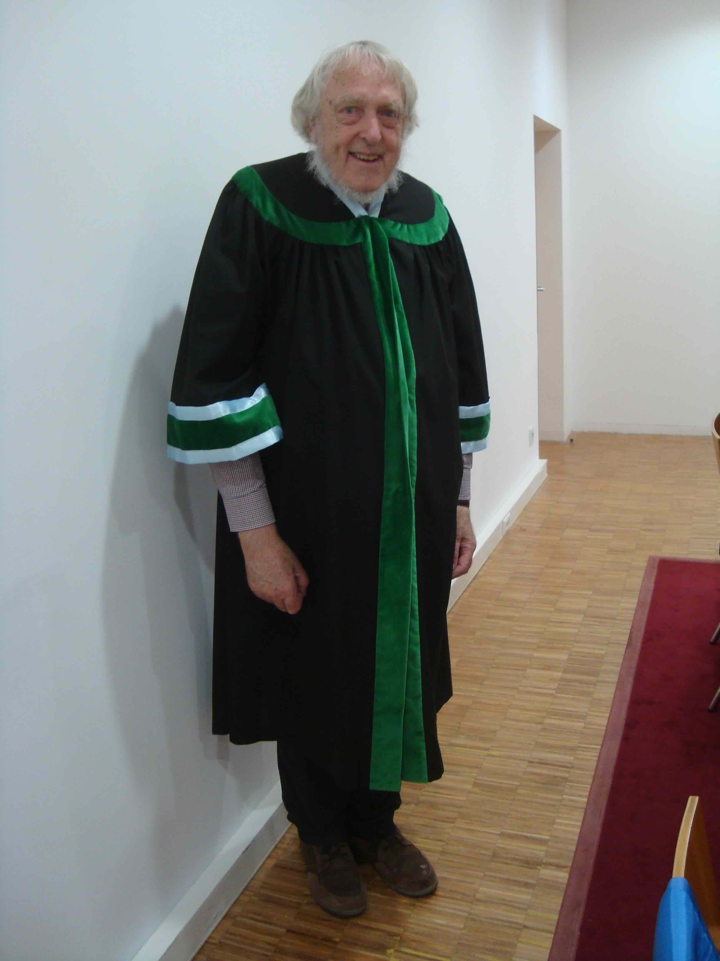
• On 20th June, Peter Cameron was on the jury for the aggregation of Maria Elisa Fernandes at the Universidade de Aveiro, Portugal, for which the jury wore academic robes. He followed this with a talk ‘The ADE affair’ The following week was spent at a workshop on the Road Closure Problem (a problem connecting permutation groups and idempotent-generated semigroups) at Herdade Maria da Guarda near Serpa (set among olive trees) in Alentejo, Portugal.

Peter Cameron resplendent in
Universidade de Aveiro robes
• Continuing their trip to South India, Rosemary Bailey and Peter Cameron visited Puducherry (formerly Pondicherry) and Chennai. At the University of Pondicherry on 12th June, Rosemary spoke to the Statistics Department on ‘How do statisticians talk to scientists?’ and Peter to the Mathematics Department on ‘Graphs and simplicial complexes defined on groups’. In the Indian Institute of Technology Madras, whose beautiful campus has free-roaming deer and monkeys, they repeated these talks to the Mathematics Department on 13th June, and on 16th June they delivered a joint talk at the Institute of Mathematical Sciences on ‘Permutation groups, lattices and orthogonal block structures’.
• Colva Roney-Dougal visited the University of Lund, Sweden on 10-11th June and gave a departmental colloquium and an algebra seminar.
• Nik Ruskuc gave an online talk entitled ‘Partitions, idempotents, projections and maximal subgroups’ at the Conference on Algebra and its Role in Computer Science held in Lisbon from 26-27th June and celebrating Misha Volkova's 70th birthday.
• Yoav Len, Violeta Lopez, and Thibault Poiret attended a conference from 9-13th June Harmonies in Moduli Spaces in Università Roma Tre in honour of Lucia Caporaso’s 60th birthday. Yoav gave a talk titled ‘From algebraic rank of divisors to compactified Pryms’, Violeta presented a poster on ‘Tropical Brill-Noether general graphs’ and Thibalut presented a poster on ‘Spaces of roots of Universal Bundles’.
• From 13-19th July Jeff Hicks is in Helmsley in the North York Moors National Park organising a summer school on Partially Wrapped Fukaya Categories. He is anticipating some good hiking in addition to fun maths!
• Several members of the School attended the joint BMC-BAMC (British Mathematical Colloquium - British Applied Mathematical Colloquium) held at the University of Exeter from 23rd-26th June. Natalia Jurga gave a morning talk entitled ‘Quantitative covering and equidistribution’ and Saeed Shaabanian gave a talk titled ‘A natural connection between recurrence Laws in ϕ-mixing dynamical systems’ in the Dynamical Systems workshop. Mike Todd and Boyuan Zhao also attended and the analysts participated in a One Day Ergodic Theory Meeting on 26th June. In the applied part, Nikolaos Sfakianakis gave a lecture ‘The mathematical hallmarks of cancer: past, present, and future’.
• Firdavs Rakhmonov delivered a talk titled ‘L^{p} averages of the Fourier transform in finite fields: orthogonal projections, incidence geometry, and the restriction problem’ at DECANTER (Diophantine Equations, Combinatorics, Analysis in Number Theory: Emerging Researchers), held at the ICMS in Edinburgh.
• Ana De Orellana gave a talk at the Workshop on Calculus of Variations and Regularity of PDEs at the University of Essex, in Colchester, which took place from 16-18th June.
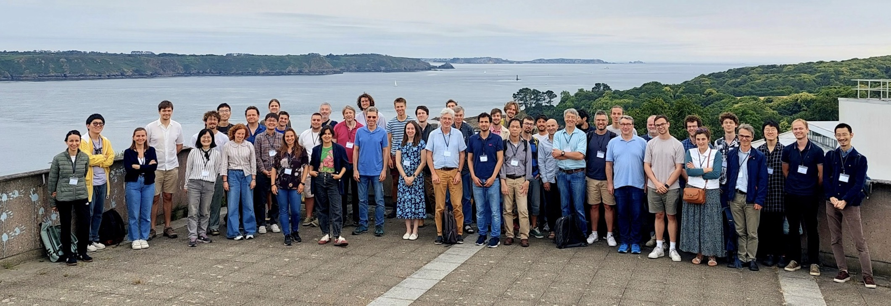
ICGAFD25 attendees taken from the Technopole in Plouzané. In the distance are the ‘Tas de Pois’, emblematic sentinels of the Finisterian tip! Can you spot the St Andrews participants?
• Jean Reinaud, David Dritschel, Daphné Lemasquerier and Xavier Carton (Université Brest Occidentale) organized the International Conference on Geophysical and Astrophysical Fluid Dynamics (ICGAFD25) in Plouzané (Brittany, France) from 23rd-25th June. The conference gathered about 60 scholars interested in nonlinear geophysical and astrophysical fluid dynamics, with topics including vortex dynamics, nonlinear waves, and turbulence in rotating and/or stratified fluids. Daphné, David and Jean all presented work, as did MMath student Murray Kiernan. Yan Barabinot, of the École Normale Supérieure in Paris, also attended, Jean having been a member of his PhD jury a few days beforehand.
• Daphné Lemasquerier gave lectures on planetary fluid dynamics at the Summer School Complex Motion in Fluids, which took place from 15-20th June on Oléron Island, an island located off the coast of France in the Bay of Biscay, south of La Rochelle.
• Several members of the Solar and Magnetospheric Theory group attended the National Astronomy Meeting in Durham from 7-11th July. Ineke De Moortel gave an invited presentation on ‘MHD wave heating in the complex solar atmosphere’ and co-organised a session on ‘Next generation solar physics – preparing for MUSE and Solar-C’. Alexander Russell co-organised a session on ‘Magnetic reconnection’ and Alexander Russell and Simon Daley-Yates co-organised one on ‘Physical processes in solar and stellar coronae’. Dan Johnson, Jonah Klowss, Anmol Kumar, Thomas Neukirch Qihui Ming, and Eric Priest also attended presenting talks or posters.
• Thomas Neukirch gave a talk entitled ‘Analytical three-dimensional magnetohydrostatic equilibria in spherical geometry’ at the UK MHD 2025 Meeting which took place at the University of Exeter on 26-27th June.
• Alexander Russell and Eric Priest attended the Royal Society Theo Murphy meeting on ‘Solar Atmospheric Abundances in Space and Time’ on 16-17th June.
• Alexander Russell attended the Hinode 18 – IRIS 16 meeting from 23rd-26th June, giving a talk on ‘Nonthermal Broadening in Candle vs. Fan Limb Flares’.
• Several members of CREEM attended the Environmental and Ecological Statistics Conference in Lancaster on 1st-3rd July (with some train cancellations and delays to make things exciting). Ali Johnston delivered one of the conference keynotes ‘People and birds: Analytical methods for citizen science biodiversity data’, Becca Supple gave an excellent talk on ‘Causal discovery in ecology’ winning one of the student talk prizes, and Hannah Worthington gave the final contributed talk ‘Efficient dynamic occupancy models for large citizen science datasets’.
•, Ben Swallow participated in an Isaac Newton Institute research retreat in Cambridge from 30th June-6th July where he continued ongoing research on spatio-temporal model calibration using Gaussian processes
• Louis Backstrom gave a talk at the International Congress for Conservation Biology in Brisbane, held from 15-19th June, on ‘Hidden observer preferences drive sampling biases in semi-structured citizen science data’.
• Isobel Falconer organised a two-session symposium ‘Circulation of ideas on field-particle dualism’ at ICHST25 (International Congress for History of Science and Technology) held in New Zealand and online from 29th June-5th July. She spoke online (at 3am UK time!) on ‘“Hypotheses are what we lack the least”: modelling matter in 1900 at the Paris International Congress of Physics’. Two others of the five speakers Chanchan Guo and Bernadette Lessel were visitors to the School last year.

Other News
• As part of the Sutton Trust programme, Rui Borges gave a practical introduction to stochastic processes through the concept of the gambler’s ruin. This involved students playing a game with odds determined by a coin flip, and they carried out simulations using R. For this, they simulated the gambler’s ruin using the odds of winning in a popular scratchcard game: 1 in 3.3. Some students even observed that stochastic effects may create the impression that a person is winning, even though they are always losing. Hopefully they have learnt that mathematics can help making better, more informed decisions in everyday situations.

Next Issue
• The next edition of the School Newsletter will be circulated in August. Items may be sent to maths-news@st-andrews.ac.uk at any time but a reminder will be sent out a week before the deadline.

