School of Mathematics and Statistics Newsletter
January 2025

Congratulations to ...
• Abinand Reddy Kodi on successfully defending his PhD thesis entitled ‘Statistical methods for camera trap surveys of snow leopard populations’ on 18th December.
• Ann Vaseekar on successfully defending her PhD thesis entitled ‘Quantifying the importance of an L4 or L5 magnetograph for modelling the global solar magnetic field’ on 18th December.

Conferences, Talks and Visits
• Rui Borges gave a talk entitled ‘A rant about mutation models in population genetics and phylogenetics’ at the annual meeting of the Population Genetics Group (PopGroup 58) held at the University of Sheffield from 7-9th January. Perhaps more importantly, he also tried his hand (feet? – Ed.) at cèilidh dancing, a cherished tradition following PopGroup conference dinners. The meeting also included the 42nd Fisher Memorial Lecture, which was given by Charles Rotimi on ‘The complex and dynamic evolutionary history of African genomes in health and disease’ which was also attended by Rosemary Bailey, Peter Cameron and Stephen Senn.
• Sophie Huczynska was an invited speaker at the Birmingham-OU-Warwick Combinatorics Meeting, a one-day event that took place on 17th December. Sophie’s talk was entitled ‘Additive triples in groups of odd prime order’. This was the first of a planned series of meetings as part of a partnership between Birmingham, Open and Warwick Universities.
• Mike Todd gave a Dynamical Systems Seminar on ‘Multivariate extremes in dynamics’ at the Open University on 15th December.
• Peter Cameron gave an online talk at a hybrid conference on Mathematical Sciences and Applications at Tezpur University in Assam, India, on 2nd January. He spoke about ‘The ADE affair’.
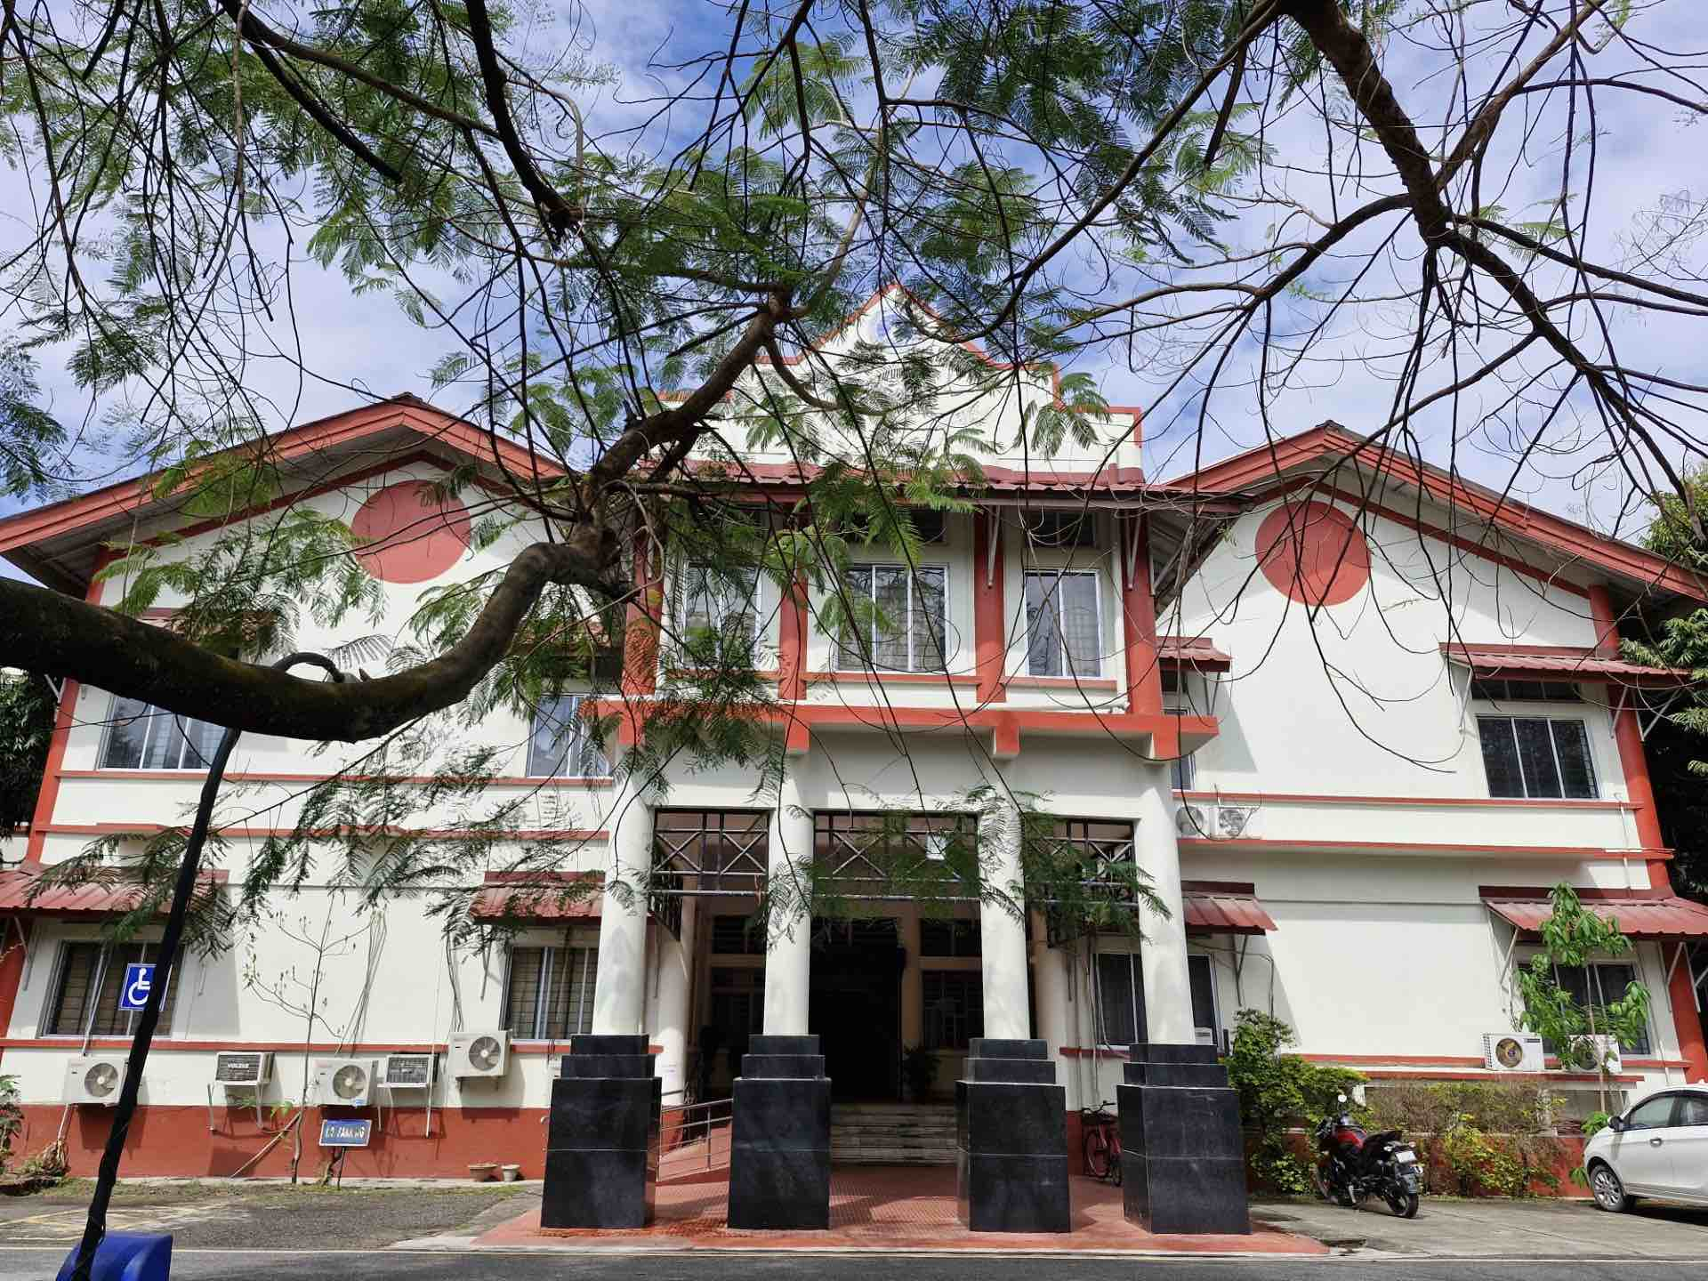

The Department of Mathematical
Sciences at Tezpur University
that hosted Peter’s talk

Other News
• Isobel Falconer and Alex Russell have been awarded funding for a Global Doctoral Studentship in collaboration with the University of Bonn, for a project ‘Continuities and discontinuities in understanding the origin of mass’. The selected applicant is expected to spend their first year in Bonn, second year in St Andrews, etc.. The closing date for applications is 21st February. Full details are available https://history-of-maths.wp.st-andrews.ac.uk/global-doctoral-scholarship-bonn-standrews/
• Deborah Kent has received a Simons Foundation Fellowship to support her participation in the Modern History of Mathematics programme at the Isaac Newton Institute in Cambridge from 8th January to 2nd May.

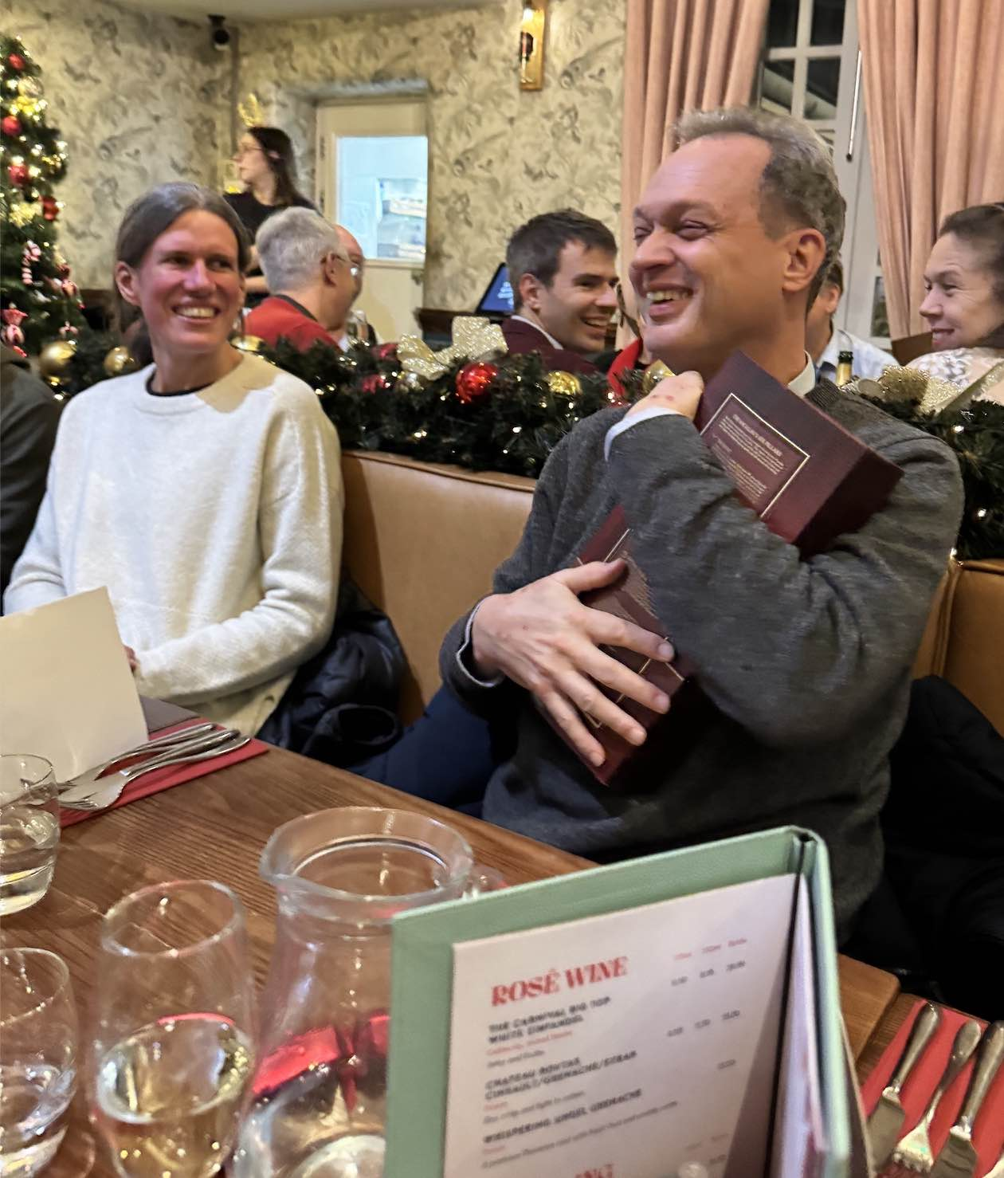
Caption Competition
• Several suggestions were received for captions for the photograph taken at Mark’s Birthday Conference. These include:
MC: “My precious” (channelling his inner Gollum)
AWS: “A few words does not equal 28 minutes!”
“To share or not to share? A 60th birthday is the perfect excuse not to share!”
“From one Head of School to another, passing on the bottle.”

Future Events
• There will be an afternoon of talks in the Scottish Dynamics Network meeting in St Andrews on Friday 24th January with presentations by Riccardo Giannini (Glasgow), Tuomas Sahlsten (Helsinki) and Reem Yassawi (Queen Mary). All are welcome and further information can be found at https://sites.google.com/view/scottish-dynamics-network/home

Next Issue
• The next edition of the School Newsletter will be circulated in February. Items may be sent to maths-news@st-andrews.ac.uk at any time but a reminder will be sent out a week before the deadline.

A Happy New Year to all our readers (both of them!)

