Access to Work Equipment Recommendations

University of St Andrews


Contents

Introduction 3
Unsupported Specialised Equipment 3
Installation at Home 3
ReMarkable – Digital Notebook 3
Specialised Equipment – IT Recommendations 4
Software 4
Hardware 6
Specialised Equipment – Workspace Recommendations 9

Introduction

An Access to Work (AtW) assessment is a tailored, confidential process—often a phone or virtual consultation—to identify specific workplace accommodations for disabled individuals. An advisor reviews how your condition affects work and may suggest tools, specialized equipment, or support workers to help you stay in or start employment.
AtW recommendations can be reviewed by the relevant departments within the University to ensure the most suitable solution is provided to you.

Unsupported Specialised Equipment

In some cases, there are recommendations we are unable to support within the university environment. A record of these recommendations is noted below, with suggested alternatives. If the assessor suggests any of these items, please highlight that we are unable to support this within the university and discuss the suitable of alternative detailed.

Installation at Home
The University is unable to visit users’ home to setup equipment or furniture. Please inform the A2W assessor if assistance for a home setup is required. The requirements will recommend a third party for installation requirements.

ReMarkable – Digital Notebook
Unfortunately, due to various limitations, this hardware does not align with our ICT regulations. The following alternative is suggested: Apple iPad, Apple Pencil and paper feel screen protector. Please discuss this alternative with your assessor to determine if it will be suitable to your requirements.

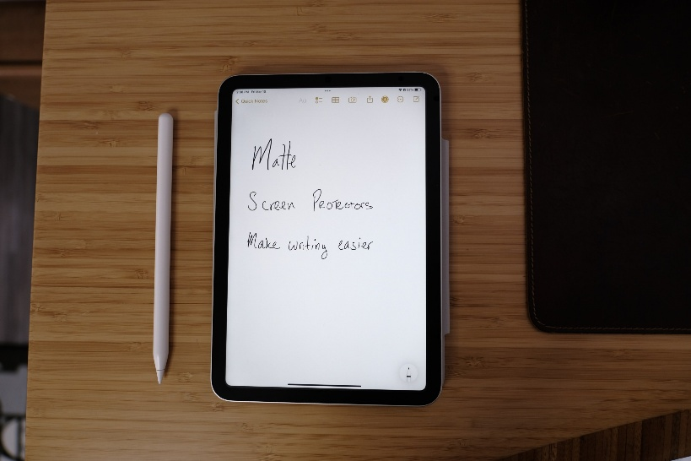
iPad and Apple Pencil

Specialised Equipment – IT Recommendations

Software

The AtW assessor is likely to recommend various software tools to assist you in the workplace. When several options are provided, we recommend using software on a trial period initially (usually a 30 day period), and then contacting IT Services (itservicedesk@st-andrews.ac.uk) to purchase the preferred software. In addition to purchasing software, your department will be required to purchase vendor support & maintenance to ensure you have specialised troubleshooting and guidance for the tool.
Previously, the university has provisioned the following assistive technology:

Speech to Text
Windows
Microsoft Accessibility Tools
Nuance Dragon Professional
TextHelp Read & Write

Mac
MacOS Dictation

Writing Assistance
Windows
Microsoft Editor
Microsoft Copilot
Grammarly Pro

Mac
Grammarly Pro

Captioning Solution
Windows
Microsoft Live Captions
Caption.Ed

Mac
MacOS Live Captions
Caption.Ed

Mind Mapping
Windows
Microsoft Visio (Web Version)
MindView AT Suite

Mac
Microsoft Visio (Web Version)
MindView AT Suite

Visual Solutions
Windows
Microsoft Accessibility Tools
Tint & Track – Screen Tinting Software

Mac
MacOS Accessibility Tools
Tint & Track – Screen Tinting Software

Teams Add-ins
Otter.ai
Browser based tools
Global Tasks
Kanban Flow

Hardware

In addition to software recommendations, an assessor may include IT hardware to help individuals with disabilities or long-term health conditions work, provided the equipment is over and above what an employer should normally provide. IT Services can discuss requirements with you and identify a device and specification that align with the AtW recommendations.
Suggested devices and upgrade options below:

Laptops
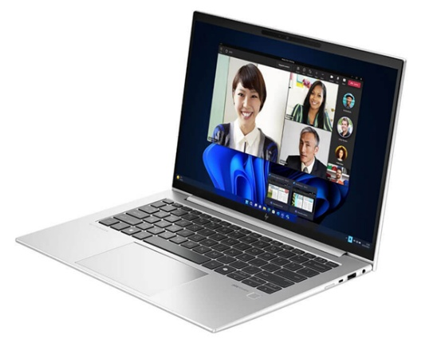

HP EliteBook 830 G11 Corporate
Processor: Intel Ultra5 (Upgradable to Ultra7)
Memory: 16GB (Upgradable to 64GB)
Storage: 256GB (Upgradable to 2TB)
Screen Size: 13.3”/33.8cm
Resolution: 1920x1200
Touchscreen: Not standard (Upgradable option)
Weight: 1.293 kg/2.85 lb

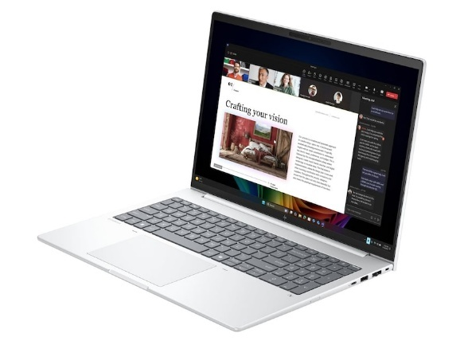

HP EliteBook 8 G1i 16 with options
Processor: Intel Ultra5 (Upgradable to Ultra7)
Memory: 16GB (Upgradable to 64GB)
Storage: 256GB (Upgradable to 2TB)
Screen Size: 16”
Resolution: 1920x1200 (Upgradable 2560 x 1600)
Touchscreen: Not standard (Upgradable option)
Weight: 1.699 kg/3.75 lb

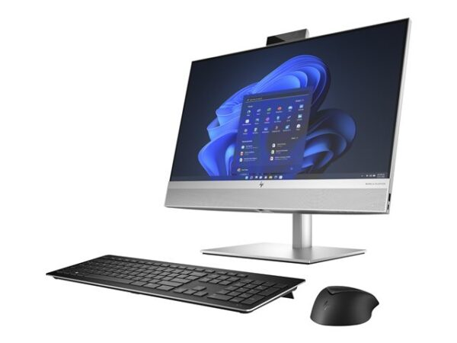
Desktops

HP All-in-One 840 G9r
Processor: Intel i5 (Upgradable to i7)
Memory: 16GB (Upgradable to 64GB)
Storage: 512GB (Upgradable to 2TB)
Screen Size: 23.8”
Resolution: 1920x1080
Touchscreen: Not available
Weight: 9.26 kg

HP All-in-One 870 G9r

Processor: Intel i5 (Upgradable to i7)
Memory: 16GB (Upgradable to 64GB)
Storage: 512GB (Upgradable to 2TB)
Screen Size: 27”
Resolution: 1920x1080
Touchscreen: Not standard (Upgradable option)
Weight: 11.6 kg

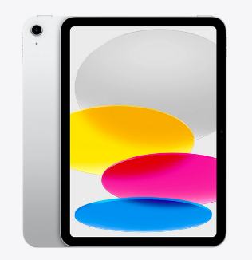
Tablets

Apple iPad
Storage: 128GB (Upgradable to 512GB)
Screen Size: 10.86”
Display: Liquid Retina Display
Weight: 1.05lb

Apple iPad Air
Storage: 128GB (Upgradable to 1TB)
Screen Size: 13”
Display: Liquid Retina Display
Weight: 1.36lb

Accessories
Ergonomic Peripherals
AtW assessors or occupation health can recommend which ergonomic variant may be suitable to an individual.
Ergonomic keyboards improve your comfort and positioning to help you work, browse and play at your computer for longer without pain or injury. The size, shape and layout of your keyboard all influence how you use your fingers, arms, hands and even your shoulders. A poorly designed keyboard can, over time, cause painful disorders and muscular imbalance (Posturite, 2026). Examples available here: Ergonomic Keyboard
A good ergonomic mouse is one that fits you: the shape and size of your hand, how much clicking, scrolling and browsing you do, and your own preferences. Ergonomic mice come in many different variants (Posturite, 2026), examples available here: Ergonomic Mice

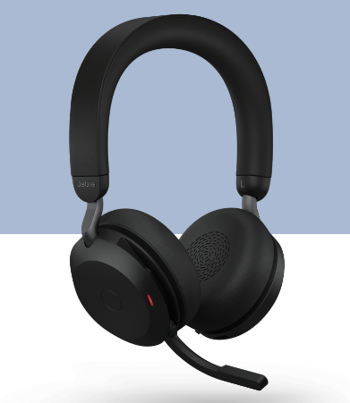

Headphones
Jabra Evolve2 75
Battery: 19 hours.
Fit: On-ear headband
Noise Cancellation: Yes
Weight: 197g

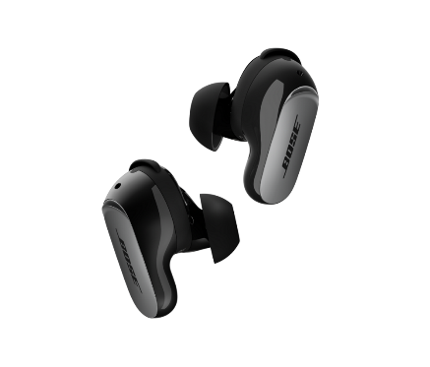

Bose QuietComfort Ultra Earbuds (2nd Gen)

Battery: 6 hours
Fit: In-ear, tips and stability bands included
Noise Cancellation: Yes
Weight: 7.7 g

Headphones suitable with hearing aids?
Mono headset
Please note, the above items are suggestions only. If you would like to explore other options, please contact the itservicedesk@st-andrews.ac.uk and copy in your EDI representative.

Specialised Equipment – Workspace Recommendations

Workplace Recommendations – large and small items

Furniture

Height-adjustable desks, ergonomic chairs, and alternative seating may be recommended for office and home working use.
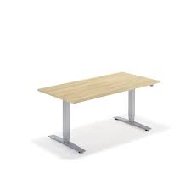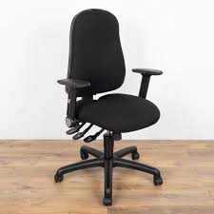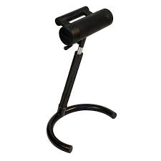

It is important to consider how they will fit into the workspace. Your local facilities manager / Estates team will be able to assist you with space measurements and any other specifics.
When large items are being supplied, check that the supplier includes delivery (to both addresses, work and home) and set up.

Desktop and surroundings
Ergonomic items for desk use, such as keyboard and mouse, may be recommended. These must be compatible with the laptop / computer setup that you use.
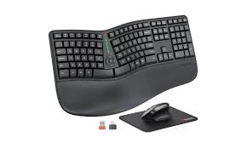

If an anti-fatigue floor mat is being ordered, check the measurements against the workspace it will be used in.
