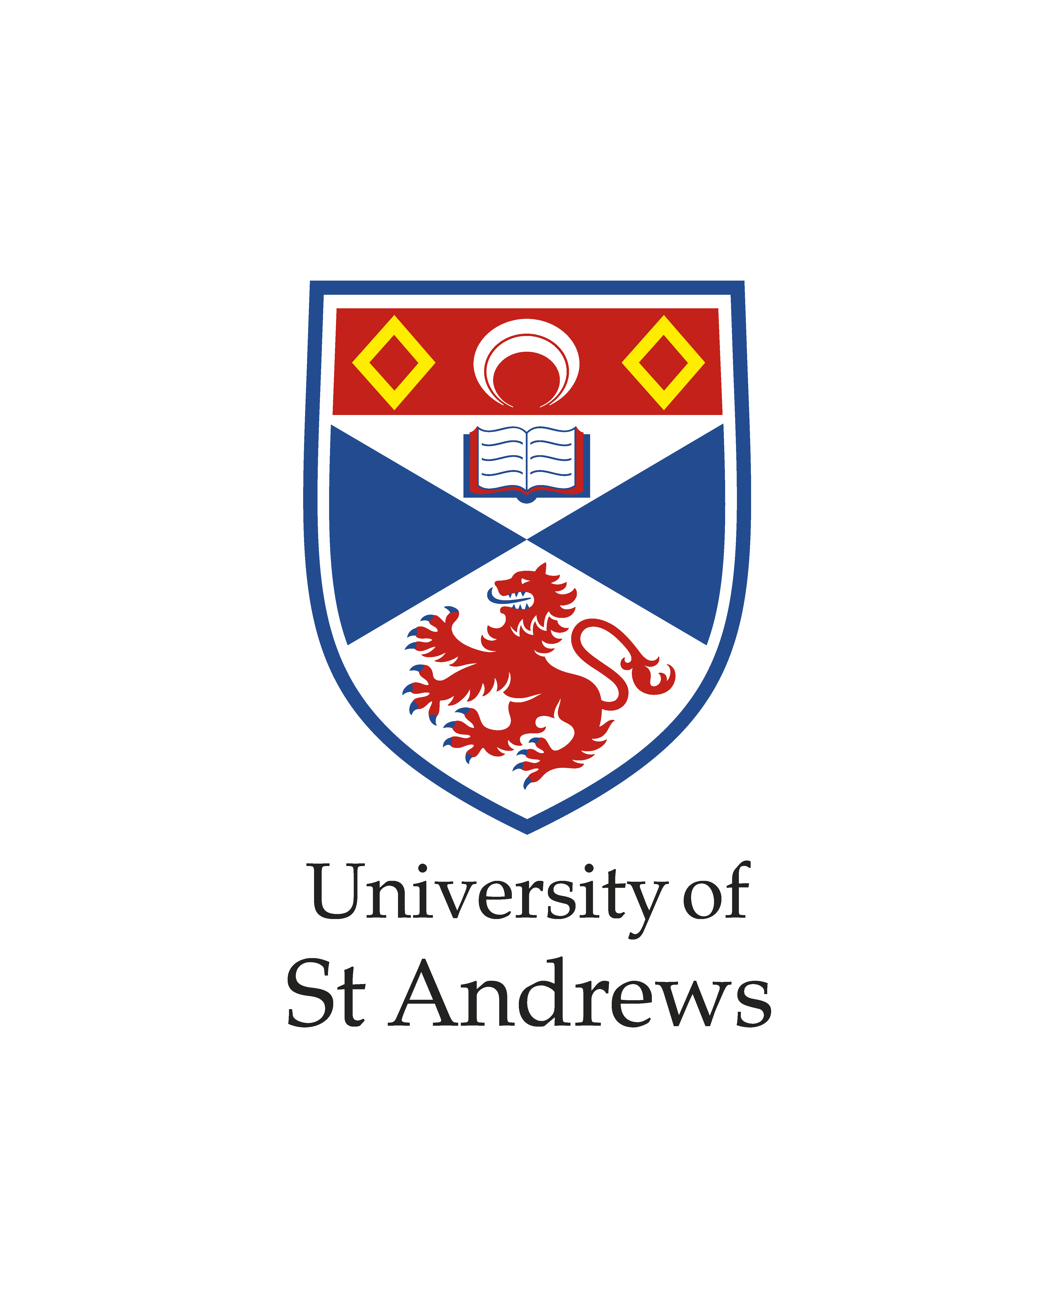
Education and Student Experience Strategy

Document type | Strategy
Scope (applies to) | Staff and students
Applicability date | 21/06/2023
Review / Expiry date | 20/06/2027
Approved date | 21/06/2023
Approver | Senate Policies
Document owner | Administrative Officer
School / unit | [Author department]
Document status | Published
Information classification | Public
EDI review/Equality impact assessment | None
Key terms | Academic policies/Quality and standards
Purpose | The refreshed University Strategy develops the World-leading, Diverse, and Entrepreneurial themes of our existing Strategy, and brings forward two others in an interconnected way for a fast-changing world – Sustainable and Digital.

Version number | Purpose / changes | Document status | Author of changes, role and school / unit | Date
1 | New Policy | New | C Young | 20-06-23

Education and Student Experience Strategy

The refreshed University Strategy develops the World-leading, Diverse, and Entrepreneurial themes of our existing Strategy, and brings forward two others in an interconnected way for a fast-changing world – Sustainable and Digital. All are underpinned by our continuing commitment to social responsibility. This document draws out the relevant aspects of the refreshed University Strategy which will be led by Education Strategic Management Group and the Student Experience Strategic Management group. The action plans arising from this strategy will be owned by each of the two Strategic Management Groups and their underpinning governance structures. Fundamentally, we will support and endorse our teaching to focus on the student experience, and the successful outcomes of our students by promoting a quality culture throughout the institution, encouraging dialogue between staff and students to ensure that we have a shared goal in the quality assurance, improvement and enhancement of our practices.

World-leading
Vision
We will be world-class across all our academic activities and support our world-leading potential. A defining aim is to address global challenges with demonstrable outcomes and in socially responsible ways.
The University of St Andrews is ambitious for the quality and impact of our educational programmes. In an environment where competition for resources and opportunities is ever fiercer, we must anticipate and be ready to act to stay ahead.

Education and the student experience
We will:
- Deliver education of the highest quality across our physical and digital environments, building on our distinctive student experience to transform the potential of future generations.
- Develop curricula and complementary opportunities integrating our research and pedagogical excellence in collaboration with students and external experts.
- Ensure students are integral partners throughout the educational and student experience as we extend our community digitally.

Diverse
Vision
We will make St Andrews a beacon of inclusivity, placing diversity and equality at the centre of everything we do and creating an environment in which all can flourish and realise their potential.
We will excel if we can attract and retain talented people with a broad range of backgrounds and if we value and mobilise the abilities of all of our staff and students. It requires always being willing to learn and to change and we will work this self-reflection into our institutional identity through dialogue and openness.

Education and the student experience
We will:
- Ensure that our teaching is at the forefront of best practice in equality, inclusion, and diversity.
- Celebrate belonging and diversity in an inclusive learning environment which supports all our students to achieve their fullest potential and be socially responsible citizens.
- Offer flexible and accessible academic programmes which support widening access, and encourage lifelong education.
- Further advance inclusive teaching practice with particular attention to curriculum design and delivery in order to support students with disabilities minimising participation gaps and attainment gaps.

Digital
Vision
We will create a digital identity, culture, and capacity that enables us to seize the opportunities which digital transformation can bring to our activities and ways of thinking, extending our ambition for our future as a leading global university.
Digital approaches, platforms, and technologies are transforming our world profoundly. Digital St Andrews will accelerate a digital way of thinking and working in education. Digital St Andrews will provide valuable avenues for intellectual growth in education. Digital education will fundamentally broaden the access global learning audiences have to St Andrews and will provide opportunities to develop our diversity and make the University more resilient. It will fundamentally broaden our reach and opportunities to engage learning communities with the knowledge and solutions we develop, and will enable capacity building globally.

Education and the student experience
We will:
- Develop digital education to reflect our values of excellence and quality.
- Embed digital opportunities and skills development in our curriculum and culture​.
- Create a digital student experience that captures the unique St Andrews experience in an authentic way.
- Extend the reach of our education and training and increase the diversity of our learners through an innovative digital learning portfolio which reflects the distinctive, individualised nature of the St Andrews experience.
- Create new and well supported online education models targeted at areas of demand in a way that represents value for learners, our Schools, and the University.
- Establish an inclusive role-based approach to development and training in digital skills that enables our staff and students to contribute and innovate, escalating their digital learning and skills.

Sustainable
Vision
We will be leaders of sustainable change at St Andrews and in the world through what we research, our opportunities for learning, and how we operate.
To effect positive change across society, and contribute to the United Nation’s Sustainable Development Goals, we will use the power of our research, amplified through education and our partnerships, to influence radical shifts in public policy and create opportunities for a rapid transition that are alive to the justice of outcomes. Sustainability sparks and requires innovation. To thrive within the finite resources of this planet we need to think in new ways about our priorities and how we achieve them. Connections to sustainability are essential for driving responsible change across the physical and digital university, as well as to enabling opportunities for growth.

Education and the student experience
We will:
- Furnish our students and staff with the knowledge and attributes that make their lives, as well as the communities around them, more sustainable.
- Prepare our students for careers in a world where sustainability issues will dominate by enriching the environmental sustainability content of the curriculum with learning from our research findings.
- Develop a teaching environment in St Andrews that minimises its environmental impact, recognising the value of our global reach.
- Provide all of our students and staff with learning opportunities to enable them to make the informed decisions required to reduce their carbon footprint and contribute to a sustainable future.
- Increase opportunities for students and staff to develop skills and knowledge that enable them to take environmentally sustainable actions

Entrepreneurial
Vision
We will encourage a culture of innovation and create an inclusive entrepreneurial ecosystem to enhance our impact on society and diversify and grow our research funding streams. This ecosystem will be created through the interactions of students and staff, through enterprise and entrepreneurial education, and through strong engagement with business, government, the third sector, and other funders.
We will encourage our entrepreneurial ecosystem, integrating entrepreneurial and enterprise education, and stepping up external engagement.

Education and the student experience
We will:
- Support and recognise the design of curricula and forms of assessment to reward risk-taking, problem-solving, and creativity, and ensure students are adept at identifying opportunities for enterprise and provide the tools to take these forward successfully.
- Promote the value of student and staff engagement with business, charity, and social enterprise initiatives​.
- Enable our staff and students, who express interest, to make the best of the ideas they generate by providing inclusive opportunities to engage with entrepreneurship through the core curriculum, co-curriculum, the Entrepreneurship Centre, and professional skills programmes.
- Support staff to embed entrepreneurship in our curriculum through the encouragement of enterprise and entrepreneurship.

Version number | Purpose / changes | Document status | Author of changes, role and school / unit | Date
1 | New Policy | New | C Young | 20-06-23

