Response rates at modular level
(subject management)
Response rates can be viewed as soon as questionnaires are open to students.
- From the Blue dashboard, click on Manage your subjects or Tasks
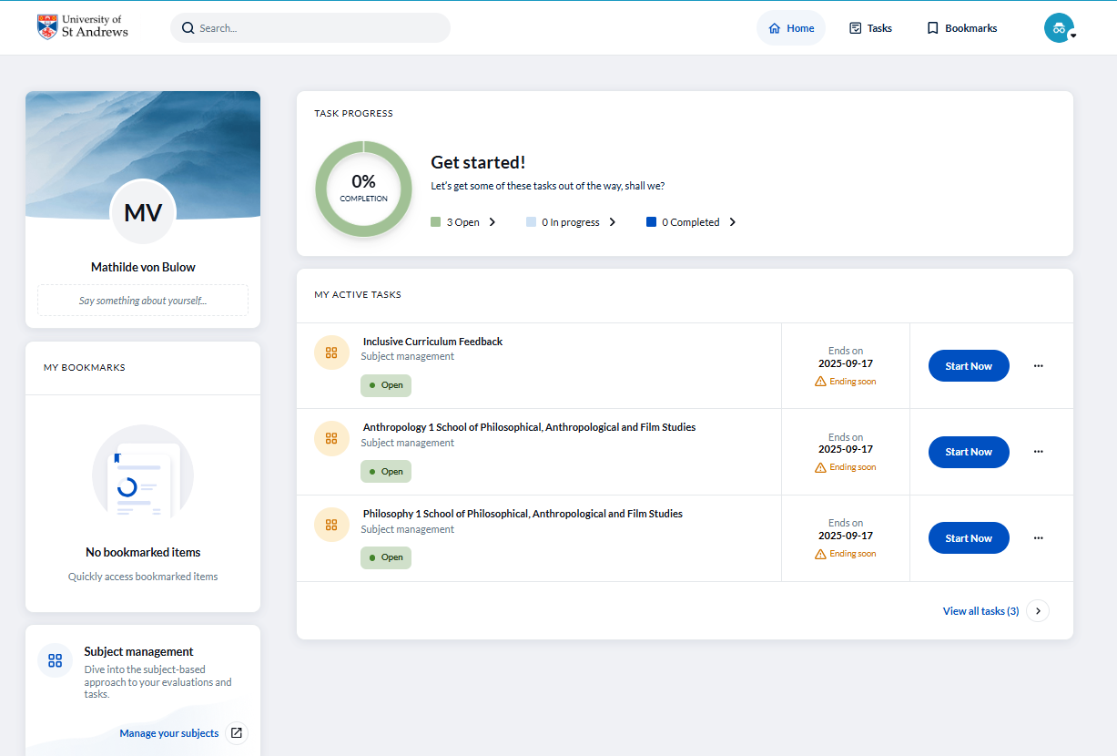
- This takes you to the Subject Management page where you can view response rates for each of your modules.
- Click the ellipsis (…) icon at the bottom right to access additional options:

- View invitees: lists the students invited to complete the questionnaire.
- View QR code: this can be shared with students.
- Manage settings: allows you to:

  - View the start and end dates of the questionnaire.
  - Preview the questionnaire from the student’s perspective.
  - Copy the QR code again if needed.
A link to view reports is available at the bottom left. A guide for viewing Reports will be available soon.

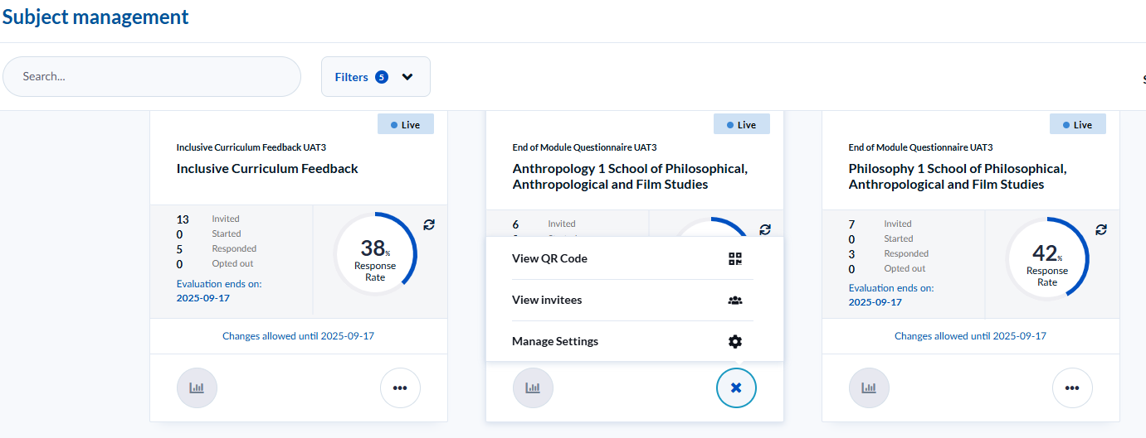
For further support, contact mfqsupport@st-andrews.ac.uk.

Response rates at modular level
Version 1 October 2025

