User Guide to the MLY dashboard
This guide provides an overview of the key functions within the MLY dashboard and explains how they can be used to analyse student feedback.

Accessing the MLY Dashboard
- Log into the MLY Dashboard
- The Get started page displays:
  - Analysis list
  - Recent activities
  - Quick analysis

Quick Analysis
The Quick Analysis feature allows users to preview the analysis of an individual comment and become familiar with the components of MLY.
To use Quick Analysis
- Copy and paste a comment into the field or select Generate a comment to create a sample comment.
- Select the analysis type: Student Experience Insights.
- Click Run analysis to review the results.
The results display Sentiments, Recommendations, and Alerts, which are explained later in this guide.
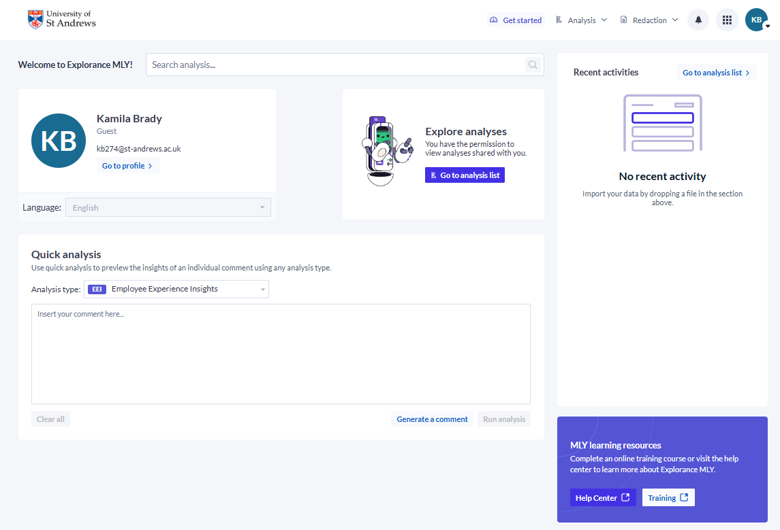

Accessing an analysis
- Click Go to analysis list
- Click Shared with me and locate the analysis you wish to view
- Click the three dots (…) next to the analysis
- Select View analysis
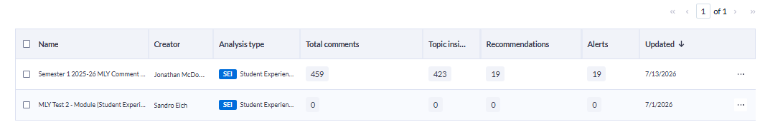

Navigating the Dashboard
The MLY Dashboard allows you to explore and interpret student feedback within your School.
How MLY categorises student feedback
MLY analyses and categorises student comments into common themes known as Topics and Sub-topics. This allows users to identify strengths, concerns, and recommendations within large volumes of feedback. A list of topics and sub-topics currently used by MLY is provided in Appendix 1.

Insights
When you access an analysis, the Insights page is displayed by default. This page contains four sections that allow you to explore and interpret student feedback.
- Summary
- Overview
- Topic Explorer
- Comment Explorer
These tools help you identify trends in student feedback, understand sentiment, explore key themes and review individual comments.
Each section within the Insights page offers a different way of exploring student feedback. This guidance outlines the purpose and key features of each section.

Filters
Filters are available throughout the Insights sections and allow you to refine the data displayed, helping you focus on specific modules, cohorts, or question responses.

You can filter by:

- Question (displayed as system-generated codes. Appendix 2 shows the codes and related questions)
- Module name or module code
- Module type
- Degree level
- Fee status

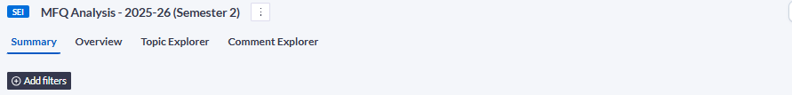

Summary
The Summary provides a high-level overview of feedback themes and sentiment across the selected analysis. This is a useful starting point for identifying key trends and issues requiring further investigation.

- Overall Summary: Snapshot of key themes and sentiment
- Alerts: Critical or sensitive feedback
- Recommendations: Suggested actions (Start, Stop, Continue, Do more/less)
- Areas for Improvement: Topics requiring attention
- Strengths: What is working well

Note: The terminology used by MLY for alerts is standardised and may not always reflect University definitions or processes. All alerts identified by MLY will be reviewed by the Academic Monitoring Group, or a subgroup thereof, and followed up as appropriate.

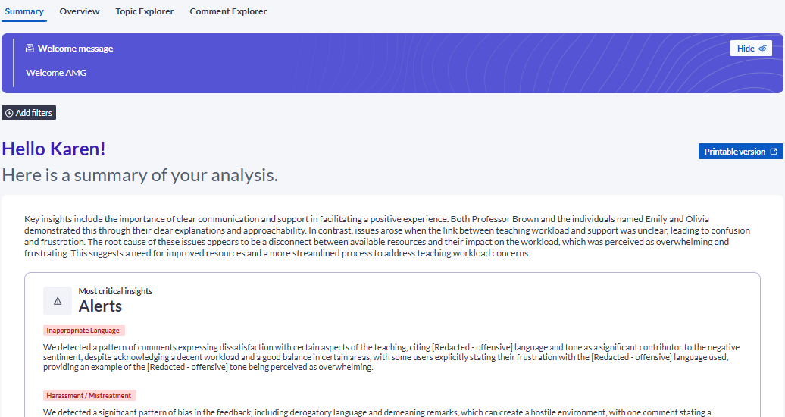

Overview
The Overview presents feedback through visualisations and summary statistics, allowing you to explore patterns across modules, cohorts, and other filtered groups.
This section shows the number of comments analysed and the general sentiment of those comments. This is then broken down by:

- Topic sentiments
- Topic recommendations
- Alert topics

Clicking on any of the labels will take you directly to the relevant category in Comment Explorer.

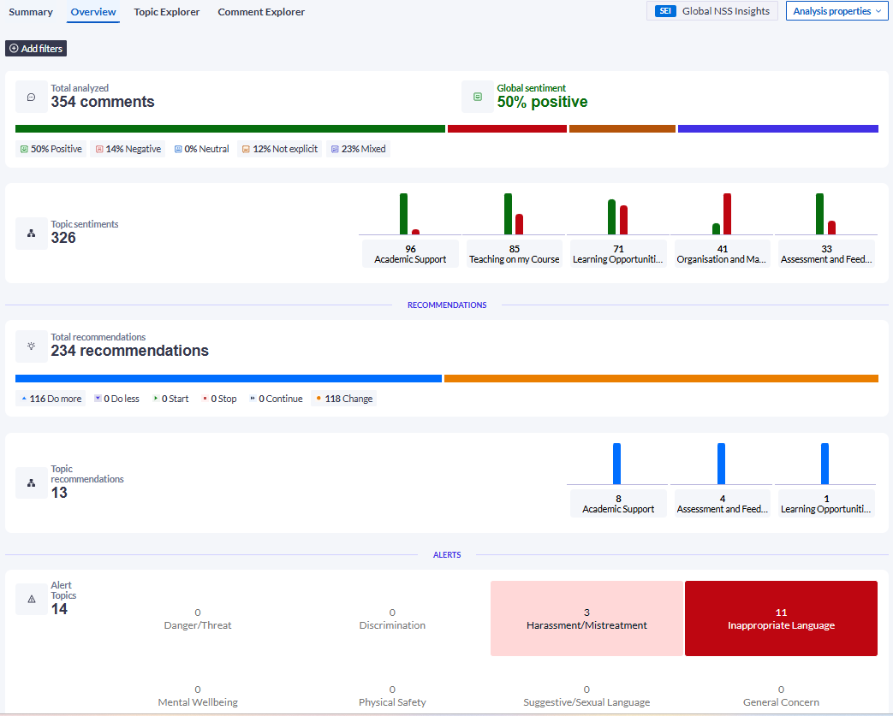

Topic Explorer
Topic Explorer identifies common themes within student comments and groups similar feedback together. This helps users understand the strengths, concerns, and recommendations most frequently mentioned by students.
In this section you can:
- View the number of comments associated with each topic and sub-topic. A list of topics and sub-topics currently used by MLY is provided in Appendix 1.
- View associated Sentiments, Recommendations and Alerts.
- Click the figures in the columns to open the related comments in Comment Explorer.
- Search for comments associated with a particular topic or sub-topic using the search bar or the Topics drop-down menu. The Topics drop-down menu provides more reliable results and is the recommended method for locating comments within specific topics or sub-topics.
- Expand topics to display sub-topics using the + icons.
The Topic Explorer provides a summary of feedback themes. To review the individual comments associated with these themes, use the Comment Explorer page.
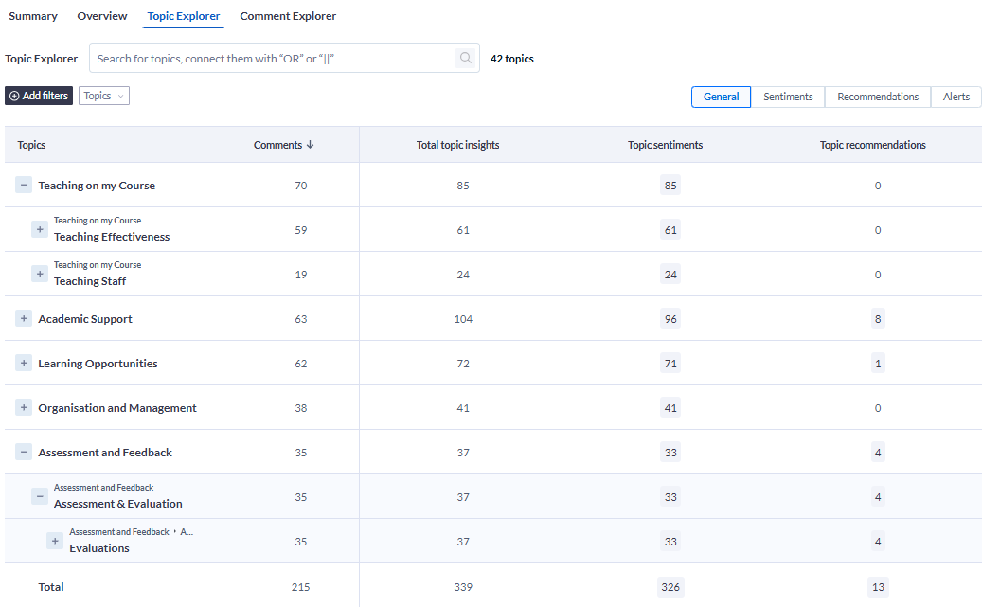

Comment Explorer
Comment Explorer allows you to view individual student comments. Filters can be used to investigate comments relating to specific modules, questions, or themes and to explore feedback in more detail.
In this section you can:
- View comments in the following categories using the drop-down menu:

  - All sentiments
  - Categorized sentiments
  - Uncategorized comments
  - All recommendations
  - Categorized recommendations
  - Uncategorized recommendations
  - All alerts
- Click Sentiment labels to refine the comments displayed.
- View the tags associated with each comment. Comments may be tagged with one or more of the following:

- Sentiment
- Topic Insight
- Alert
- Recommendation
- View the survey question associated with each comment using the ? under each comment.
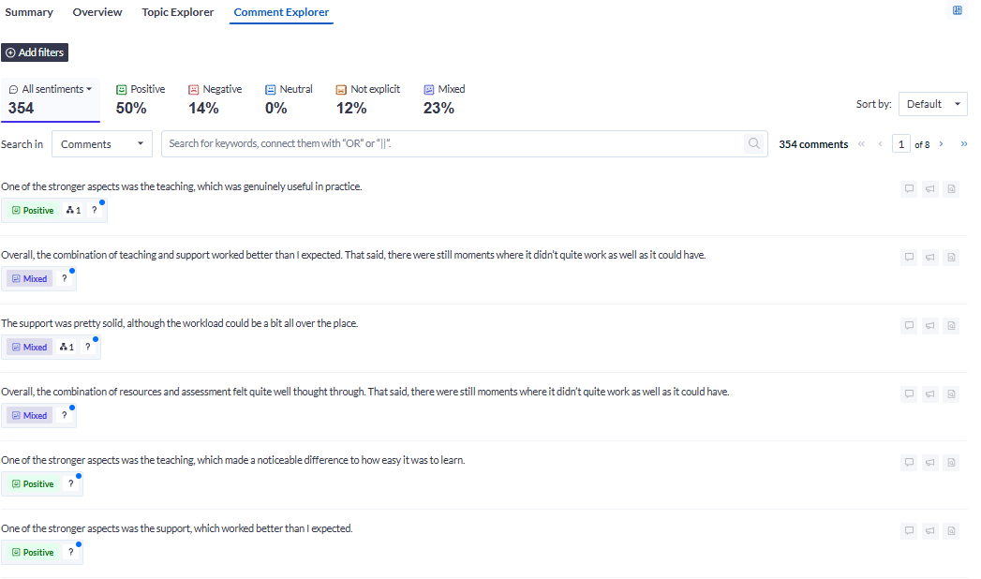
For further information about MLY functionality and advanced features, please refer to the Explorance documentation. Should you have any questions regarding this guidance or the use of MLY, please contact mfqsupport@st-andrews.ac.uk.

Appendix 1: MLY Topics and sub-topics
MLY is set to use a custom text analytics model that aligns student comments with themes commonly associated with the National Student Survey (NSS). The model groups comments into ten high-level topics, including themes aligned to the NSS alongside additional institution-focused areas. These topics are then broken down into more detailed sub-topics to support deeper analysis of student feedback.
The topics and sub-topics currently used within MLY are listed below. The topics identified within an analysis will vary depending on the content of the student feedback received. As a result, some topics or sub-topics may not be represented and may show zero results.
Topic | Sub-topic
Teaching and learning | Teaching and delivery methods  Classes and programme delivery  Teaching style and quality  Lab technicians  Teaching Assistants (TAs) and tutors  Teaching staff
Academic support | Academic support  Support from staff  Helpfulness and availability of staff  Communication with staff  Advisors and counsellors  Staff representatives
Institutional feedback | Institutional feedback mechanisms  General feedback processes  Student satisfaction overall  Value for money  Student expectations
Learning resources | Library services  IT and technology systems  Study spaces  General Campus facilities supporting learning  Course materials
Assessment and feedback | Assessment processes  Evaluations  Assignments  Feedback and quality timeliness  Exams  Grading  Assessment and feedback overall
Student Voice | Student voice  Participation in decision-making  Feedback channels  Student representation
Mental health and wellbeing | Wellbeing services and programmes  Work-life balance and study-life balance  Physical health support  Mental health support  Wellness initiatives
Learning Opportunities | Methods of learning  Learning opportunities  Workload  Practical learning experiences  Course materials  Learning outcomes  Engagement in learning  Guest lecturers and speakers
Organisation and Management | Organisation and management  Administration processes  Organisation and management support  Course registration  Communication from institution  Timetabling systems
Campus services | Student services  Campus services  Events  Student engagement  Housing  Campus life  Environmental, social and governance (ESG) initiatives  Career planning support  Athletics and sports  Internships and placements  Commute and travel  Networking opportunities  Clubs and societies  Graduate employability support  Fitness activities  Sustainability-related activities  Careers services  Food and dining services  Student life  Parking

Appendix 2 - Question Codes
Within the MLY dashboard, survey questions are currently displayed using system-generated codes rather than the full question text. The table below shows the codes currently used and the corresponding survey questions. Explorance has advised that a future update will display the full question wording.

The current codes relate to the following questions:

Code | Question
Standard credit-bearing modules
Q8ROW1 | What are the strengths of this module
Q9ROW1 | What aspects of the module could be improved to better support your learning?
Q10ROW1 | Please use this space if you wish to give any staff member (including postgraduate tutors/demonstrators) special mention.
Dissertation modules
Q26ROW1 | What are the strengths of this module.
Q27ROW1 | What aspects of the module could be improved to better support your learning?
Q28ROW1 | Please use this space if you wish to give any staff member (including postgraduate tutors/demonstrators) special mention.
VIP modules
Q44ROW1 | How has this project helped you develop your research capabilities?
Q45ROW1 | How has this module helped you gain employability skills?
G48ROW1 | What knowledge and skills have you developed by taking part in this VIP project?
G49ROW1 | How can the project be improved for future participants?

