Module Feedback Questionnaire (MFQ) reports
This guide explains how to access MFQ reports after questionnaires have closed. Reports become available on the Monday morning following the closure of the questionnaire.
Visibility of reports is governed by role-based access as detailed in the section below - Report access by role.

Access Reports
- Log in to the Blue dashboard.
- Click Reports at the top of the screen or My Reports further down the page.

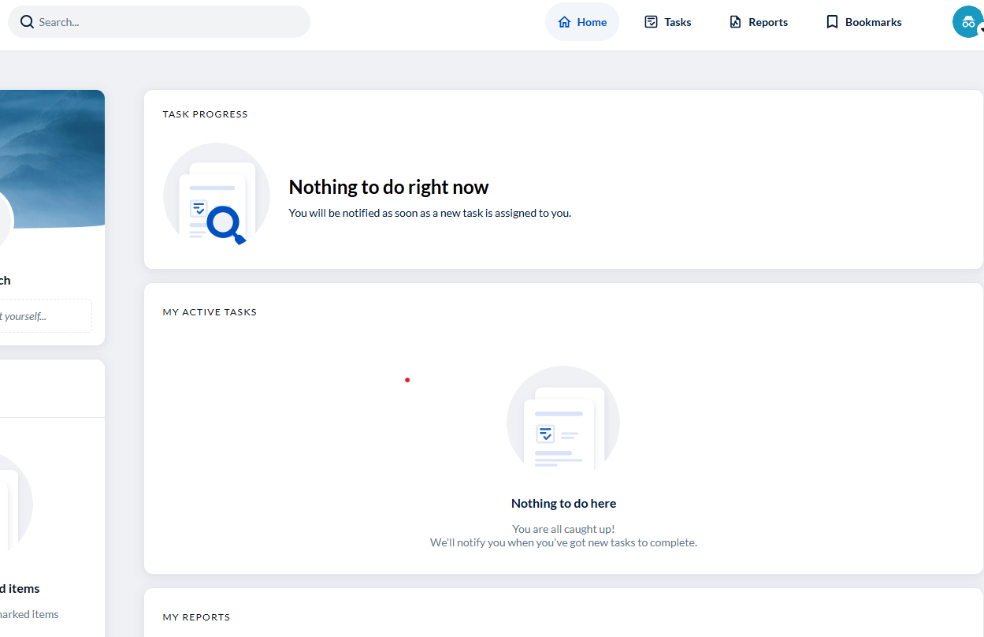
You will see a list of your available reports. Use the Search box to find specific reports by:
- Module number or title
- Department or School
- Academic year or period, for example, S1, S2, Summer.
Filter Options
You can refine the displayed reports using the following filters:
- Category: by questionnaire or report level, for example, School, Department or module, depending on your access permissions
- Date range: dates when reports were published
- Availability: current or archived reports
- My reports filters: after selecting your filter options, click Save filters on the right to reuse them in the future.

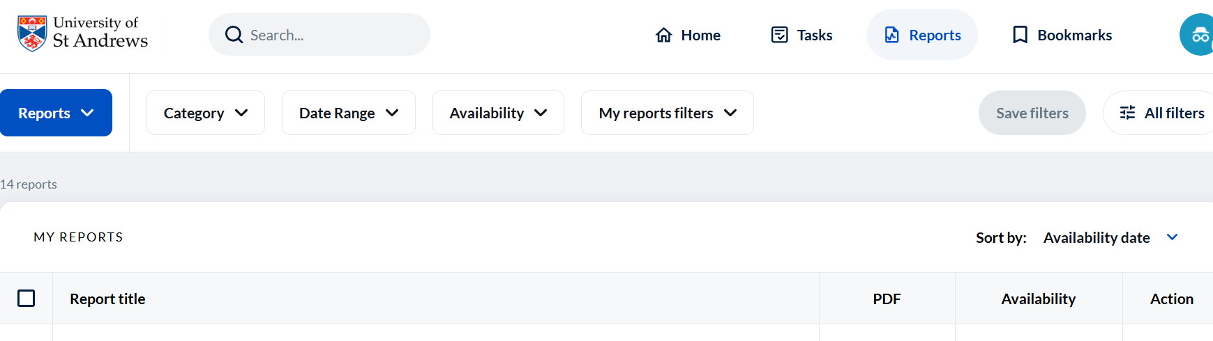

Reviewing and downloading reports
- Reports can be viewed online or downloaded in pdf and csv formats
- Each report includes a coversheet summarising how to interpret the data and analysis.
Please note that when downloading data in a csv format the results are duplicated due to how the data is held within the Explorance Blue system. As such you should look to remove these duplicates before using the csv export for local analysis. To do it, navigate to the first column ('Secondary Subject ID') which lists all lecturers/ tutors associated with the module, and filter out multiple IDs to only display one (any) staff ID.
Further questions on how these reports are generated, the calculations within, or support for further analysis can be sent to mfqsupport@st-andrews.ac.uk.

Report access by role
Access to reports depends on your role(s) as defined in MMS.
Report level | Module | Module | Department | School
Content type | Numerical responses only | Numerical and free-text responses | Numerical responses only | Numerical responses only
DoT and DoPGT | No | Yes | Yes | Yes
HoS, HoD, and Administrators | No | No | Yes | Yes
Module Coordinator | No | Yes | No | No
Lecturer, tutor | Yes | No | No | No
Table 1: Access permissions for reports by role and level
Directors of Teaching and Directors of Postgraduate Studies (Taught) may share Module level reports with the Head of School on an ad hoc basis, as required.

Reports
Version 1 December 2025

