MEQ: Adding school optional questions

Table of Contents
Getting started 1
Account information 1
Creating your question block 1
Question block details/properties 2
Question groups and questions 2
Editor control 2
Top menu 4
Question types available 4
Adding the question 5
Saving question block once finished 5
Amending an existing question block 5
Editing question blocks 5
Activating your question block 6
MMS log in 6
Configuring and updating modules using MMS 6
MMS: evaluation configuration 7
Saving your settings 7
Support 8
School MEQ contacts 8
General 8
Appendix 1 9

These notes provide the knowledge and processes required to add/amend the optional school questions within the MEQs. Each school can have up to a maximum of 5 questions for each module.
If you are using the same question blocks as previously, you can bypass these notes and just enter the same code into MMS as it would already have been authorised for last time.

Getting started
- EvaSys web link: https://www.st-andrews.ac.uk/evasys/

Account information
Log in to the system using the account details provided. School usernames (see Appendix 1) and the password should be with the MEQ contact for your school. If you are taking over from someone, the previous person should have the account details.
It is important not to change the password as the account may be used by other colleagues within your school, who have a role in the MEQs.

Creating your question block
Once logged in you will see the following screen:
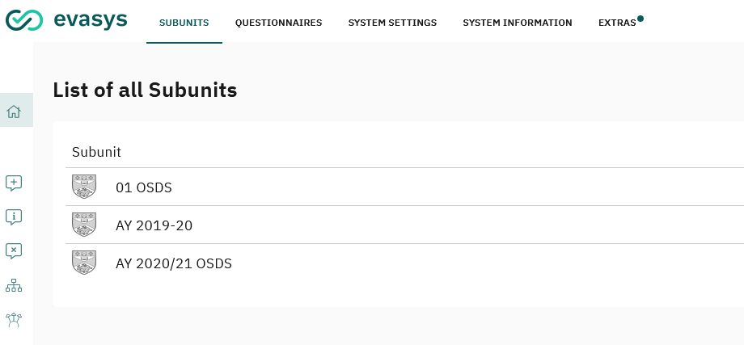
(1) Select ‘Questionnaires’ from the top menu.
(2) Select ‘Create Questionnaire’ from the Questionnaire menu on the left.
(3) Select ‘Vividforms Editor’ (left option)

Question block details/properties
The form wizard will automatically appear for you to enter the question block details.
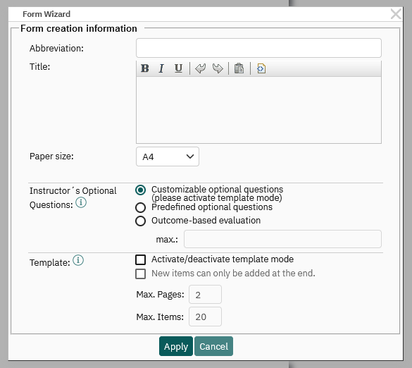
The ‘Abbreviation’ and ‘title’ are used to identify the question blocks, and to authenticate them for MMS.
(1) Abbreviation – must have 5 to 25 characters, no spaces, meaningful e.g., module code, honours, sub honours and so on.
(2) Title – description of block e.g., questions for honours students, and so on.
(3) Paper size – A4
Please ignore the rest of the options as these should remain at the default.
(4) Click on ‘Apply’.

Question groups and questions
Question groups hold the questions, so to add questions you first need to create a Question group. You can leave the group title blank or add meaningful text. Please note this text will be displayed within the live MEQ.

Editor control
There are 7 different sections within the control panel offering various options, but we will only need to use the top 4 of these sections:
- Add
- Edit
- Clipboard
- Move
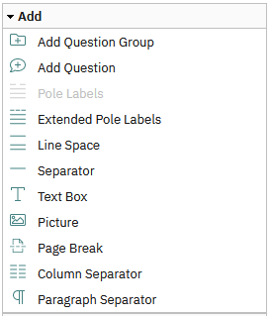
Add – question groups, questions, spaces, separator (line) and text box for extra information. Please ignore the other options.
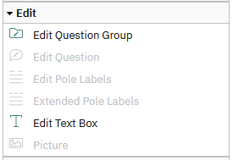
Edit – amend and update question groups, questions, and text boxes. Please ignore the other options.
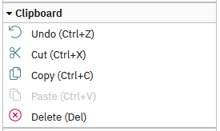
Clipboard – copy, cut, paste and delete elements from the question block or undo your previous actions.
Move – rearrange order of the questions.

Top menu
There are options along the top that allow you to Save and view the question block.
Save and Exit – unfortunately there is no ‘do not save’ option with EvaSys, so if you make a mistake you can use ‘undo’
Form properties – can edit question block ‘abbreviation’ and ‘title’ that identifies the block.
Previews – switch between the different views of the question block.

Question types available
There are eight question types but only four of these are used in the MEQs:
- Scaled question
- Open question
- Single choice question
- Multiple choice question
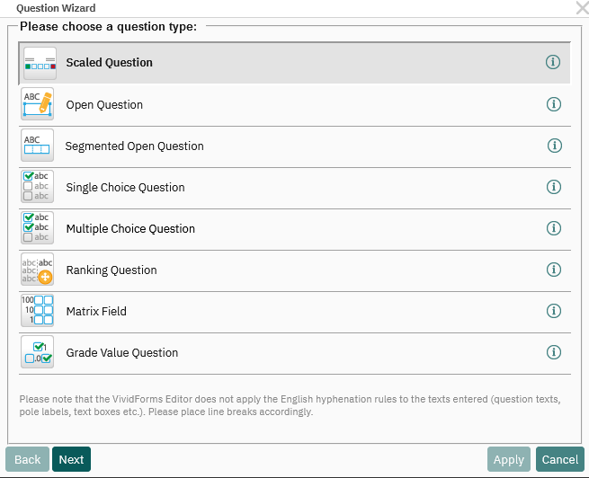

Adding the question
(1) Select ‘Add question’ from the Editor Control menu on the left side.
(2) Select the required question type from the Question Wizard that pops up. Please note the MEQs only use scaled, open, single and multiple-choice questions.
(3) Follow the instruction for the question type selected:
Scaled question
- Enter question in blank text box at start.
- Ensure that the Individualised pole labels are ticked, and enter the scale values to go either side of the scale i.e. excellent/poor, strongly agree/strongly disagree.
- Leave the rest of the information as ‘default’ and click on ‘Apply’.
Open question
- Enter question in blank text box at start.
- Settings – limit characters to a maximum number (optional)
- Leave the other information as default and click on ‘Apply’
Single choice question
- Enter question in blank text box at the start.
- Enter options, clicking on ‘Add option’ after each individual choice. Amending options – select option from list displayed and either: move (up/down), edit or delete from the menu on the right side of the list.
- Leave the rest of the information as default and click on ‘Apply’.
Multiple-choice question
- Follow the instructions and enter the details in the same way as the Single choice question.
- Limit choice options (optional) – you can limit the number of options a student can select.

Saving question block once finished
Just click on ‘Save and Exit’ option in the top menu.

Amending an existing question block

Editing question blocks
Once the question blocks have been created and used within the MEQs, it locks the block, so you are unable to make any amendments. However, up until the point the block has been used you can still edit the block.
The padlock alongside the question block (in the Questionnaire section) indicates the block’s status:
- Open padlock – indicates that the block is still editable and can be updated or amended.
- Closed padlock – indicates the block has been used with data collected and is no longer editable.
(1) Select ‘Questionnaires’ from the top menu.
(2) Beside existing question block, select ‘copy’ from the drop-down menu.
(3) Leave settings as default and click on ‘Copy’.
(4) Find the [copy] within the list – usually under the block you have just copied.
(5) Select ‘Edit’ from the drop-down menu.

Activating your question block
For your questions to be included within your module evaluation(s), you will need to activate the question block. This is achieved using the following process:
(1) Abbreviation and Title of question block – note down the abbreviation and title of the question block(s) you require activated.
(2) Email information to Carina Evans: module-evaluation@st-andrews.ac.uk
(3) Question block will be checked to ensure it meets with requirements (e.g., only 5 questions) and activated to enable the link with MMS.
(4) The validation code (for MMS) will be emailed to you.
(5) Enter the MMS validation code within MMS (guidance overleaf), and your question block will be good to go. The optional questions will appear within the module(s) you have entered the code.
Please note question block validation codes can be used with more than one module, just enter the code into the required module(s).

Configuring and updating modules using MMS

MMS log in
https://mms.st-andrews.ac.uk/mms//
Log in using your university username and password.

The evaluation software (EvaSys) uses MMS (Module Management System) to get access to information on:
- Number of students on module.
- Staff (lecturers and tutors) teaching on a module.
- The roles staff have been assigned within MMS (e.g., report recipients, module coordinators, tutoring, etc).
Ensure modules on MMS are up to date i.e., additional lecturers/ tutors, staff no longer involved or on research leave.
Once data has been collected, we are not authorised to ‘tamper’ with it as it would render the data unreliable. This includes removing data for staff who were evaluated and are no longer involved with the module, were on research leave and so on.
Please note it’s the school’s responsibility to ensure that MMS is kept up to date within the deadlines provided. For dates, deadlines and other MEQ related information please visit the University MEQ page: https://www.st-andrews.ac.uk/education/staff/academic-monitoring/module-evaluation-questionnaires/

MMS: evaluation configuration
(1) Select ‘Get all modules’ or use the search facility to look for a module.
(2) Click on the module code and title which takes you to the Module Overview page.
There are 3 fields within the evaluation section:
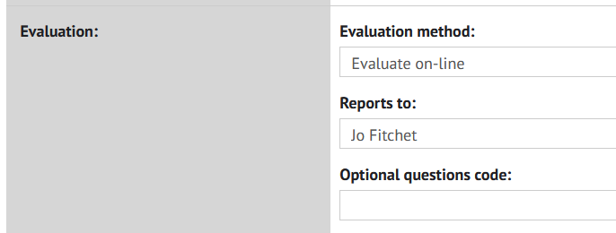
(3) Complete the fields as follows:
Evaluation method – depending on the option chosen, the relevant university questions will automatically be added to the MEQs. The options are as follows:
- Do not evaluate – for modules not running this semester.
- Evaluate on-line
- Evaluate on-line, Dissertation/ Project module
- Evaluate on-line, Group Dissertation/ Project module
Many of the dissertation modules (i.e., PGT Masters dissertations) are evaluated during the summer when they are handing in their dissertations.
Report recipient – a person must be allocated even though emails are no longer sent out from the system. This is required for the link between MMS and EvaSys. No emails will be sent as the MEQ data can be obtained by the relevant staff through MMS.
Optional questions code – enter relevant MMS validation code that you received from me so that your optional questions can be added to the MEQ when generated. Or leave blank if no optional school questions are required.
Note: if you have more than one optional question code to input, there is a quick way to do all the modules at once. From the ‘Home’ (screen that lists all modules):
- Click on ‘View School’ from top menu.
- Click on ‘Module evaluations’ under Set Up.
This brings up the list of all modules for the current academic year (e.g., semester 1, semester 2 and yearly) but you can re-arrange the order by sorting the modules by the Semester column (use the arrows).

Saving your settings
Double check your settings are entered correctly then ‘Save changes’ to save your configuration (‘update Module Evaluation’ if you are using the list of modules option).

Support
Support is available should you have any problems or queries regarding the information within these notes or about the MEQ process in general. Please email Carina Evans: module-evaluation@st-andrews.ac.uk
There is also a University MEQ web page which includes the core questions for the MEQs, dates and deadlines, school MEQ contacts and other relevant information.

School MEQ contacts
If you notice an error within the contacts list, please let me know (module-evaluation@st-andrews.ac.uk) as this list is used to distribute information about the MEQs (e.g., deadlines, problems and any other relevant information) so it’s important that the correct people are listed.
Two contacts are required in case either is on holiday or are not accessing their emails.

General
If you have any MEQ related problems or queries, please feel free to contact me: module-evaluation@st-andrews.ac.uk

Appendix 1
School usernames
School | Username
Art History | arthistory
Biology | biology
CEED | capod
Chemistry | chemistry
Classics | classics
Computer Science | compsci
Divinity | divinity
Earth & Environmental Sciences | earthsci
Economics & Finance | economics
English | english
Geography & Sustainable Development | geosd
Graduate School | graduate
History | history
International Education Institute | elt
International Relations | ir
Management | management
Mathematics & Statistics | maths
Medicine | medicine
Modern Languages | modlangs
Music | psafsm
Philosophy, Social Anthropology and Film Studies | psafsm
Physic & Astronomy | physics
Psychology & Neuroscience | psychology

