Closing the feedback loop – module coordinators
After reviewing student feedback from the questionnaires (MFQs), Module Coordinators must complete the feedback loop in Blue. This should be a concise reflection based on the feedback received in the end of module MFQ, referencing the pulse MFQ, where relevant.
Feedback responses will be shared with all students once the closing the feedback loop task closes. Staff are encouraged to discuss feedback responses with external examiners at Module Boards.

Steps to complete the feedback loop
- Log into the Blue dashboard. You can access the dashboard using this link or via the link provided in the email you receive notifying you that the Closing the feedback task is open.
- Modules that require action will appear under My Active Tasks, or you can click Tasks at the top of the page.
- Click Start Now next to the relevant module. This opens the Welcome message.
- Click Start Now when you’re ready to add your text to complete the feedback loop.

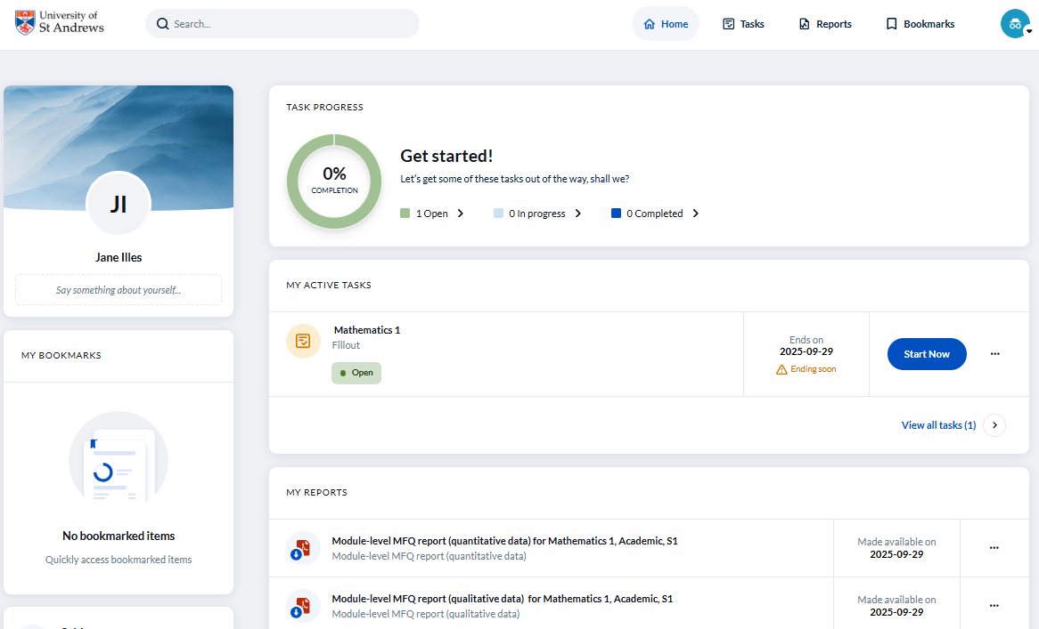
- Enter your response into the text box.
- Once you’ve entered your response, click Next to review it on the Summary page or Save to return later.
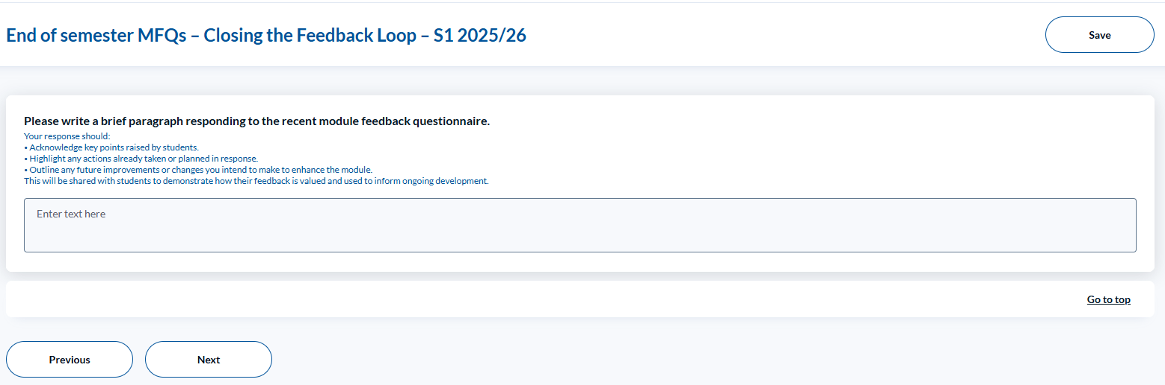
- On the summary page, click Modify to make any changes to your text or Save to save your progress and return to complete it later, or Submit to complete the process.
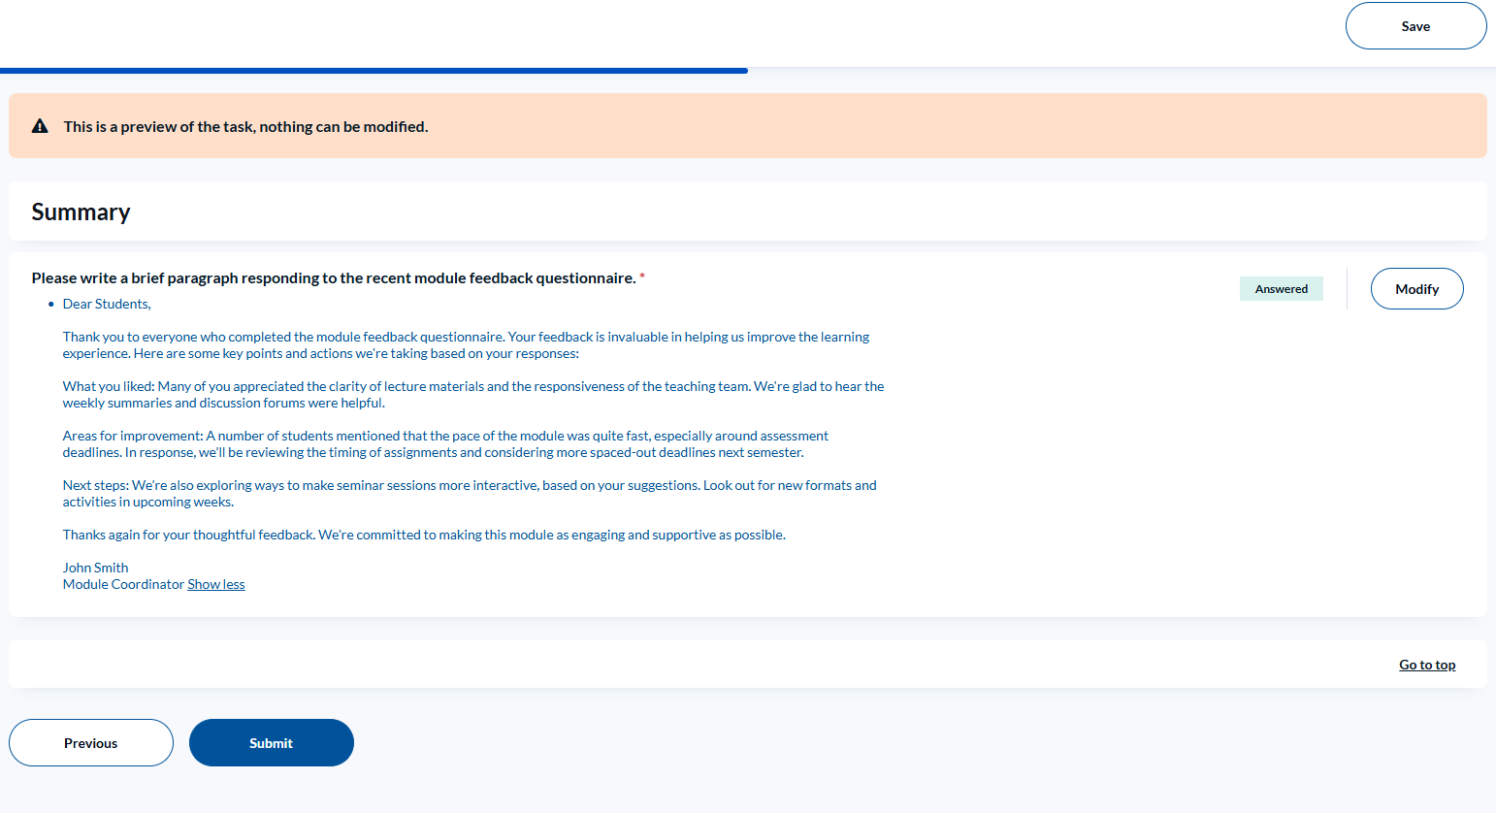
If you choose to save and return later, the task will show as In progress on your task list.
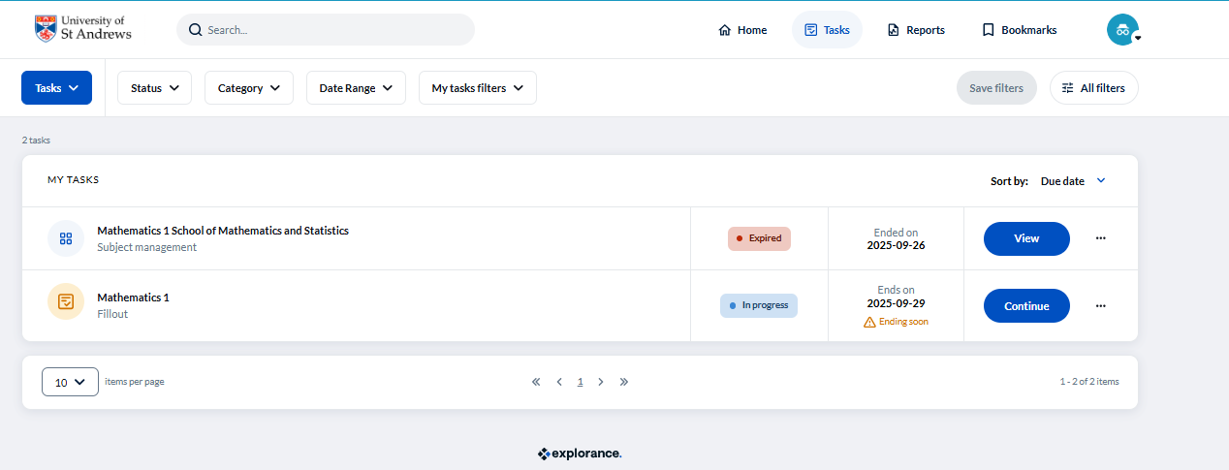
Once submitted, your response will show as Completed. Please ensure all responses are submitted before the feedback loop closes.
Students will be able to view your submitted responses after the feedback loop closing date.
For further support, contact mfqsupport@st-andrews.ac.uk.

Closing the feedback loop
Version 2 December 2025

